Letter Sound | Action | Song
y  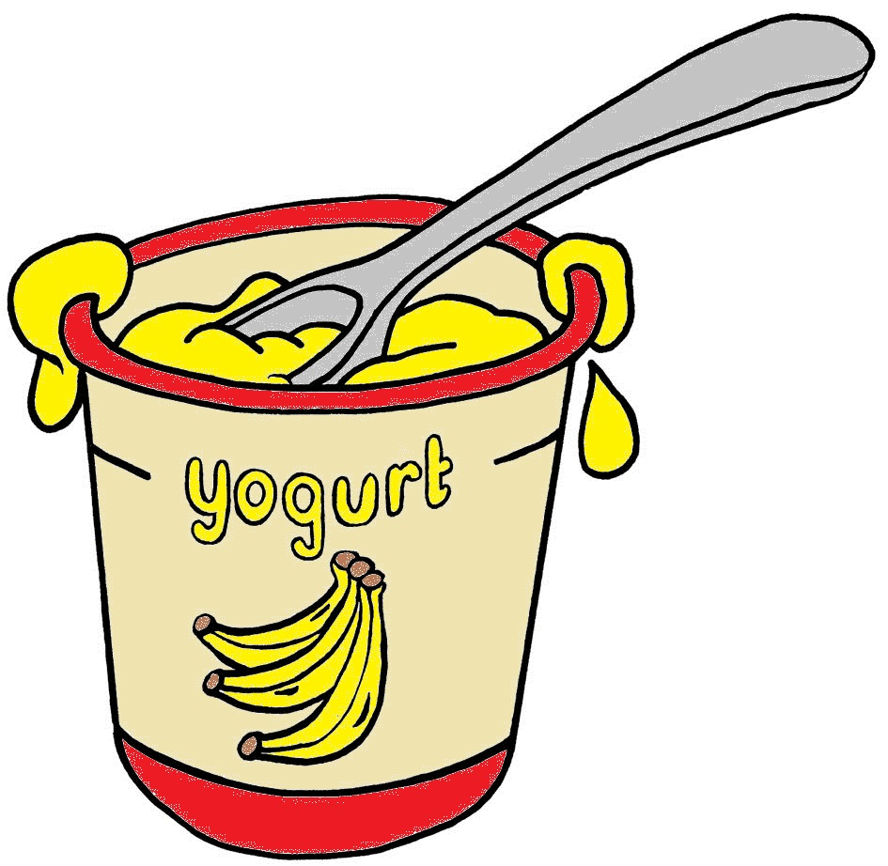 | Pretend to eat yogurt from a spoon saying y,y,y,y.  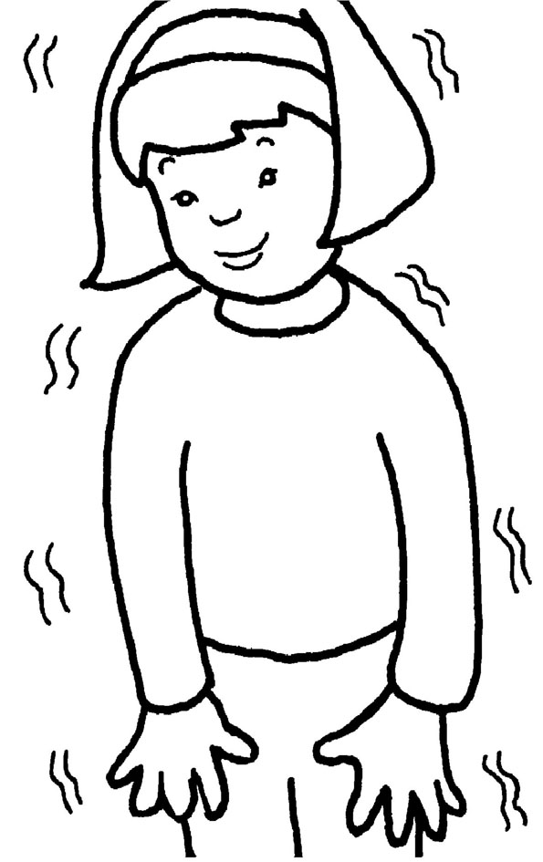 | (Tune: Apples and Bananas)  I like to eat, eat, eat,  yogurt and bananas.  I like to eat, eat, eat,  yogurt and bananas.  I like to eat, eat, eat,  yogurt and bananas  - /y/-/y/-/y/-/y/-/y/!

Letter Sound | Action | Song
z  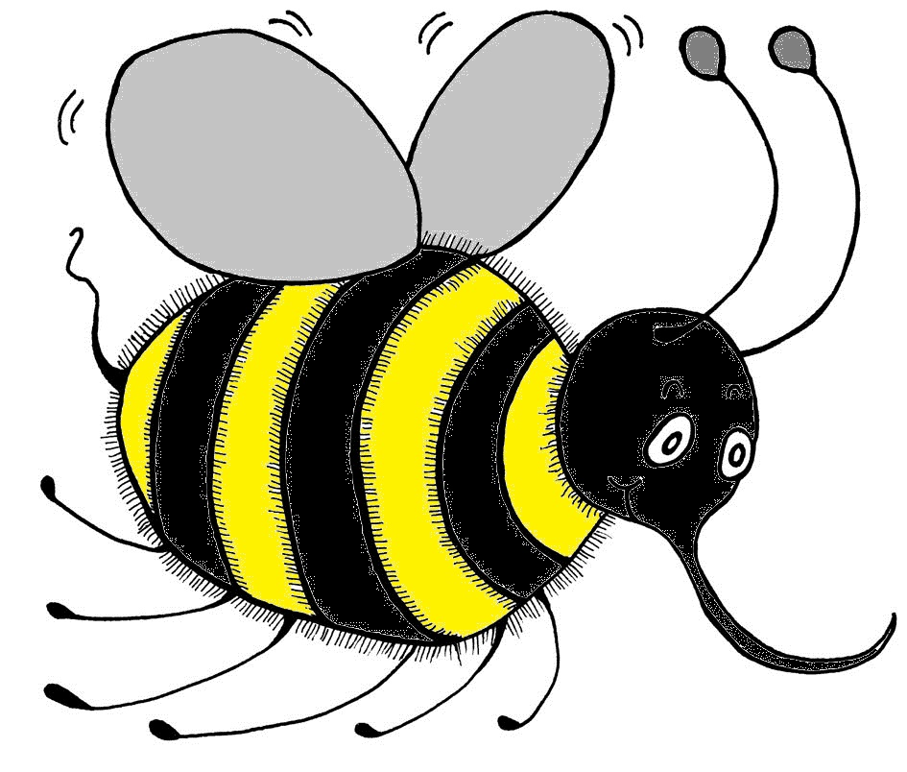 | Put your arms out at your sides and flap them like a bee, saying zzzzzzzzz.  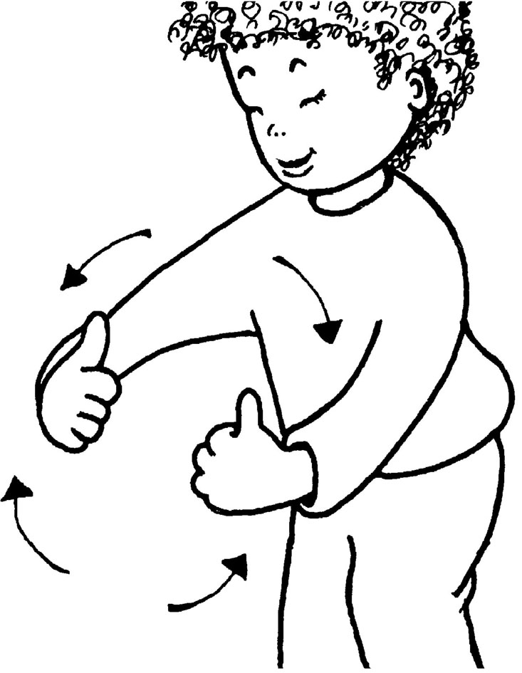 | (Tune: Did You Ever See a Lassie?)  Did you ever hear  a bee buzz,  a bee buzz,  a bee buzz?  Did you ever hear  a bee buzz,  “/zzz/!”, like this?

Letter Sound | Action | Song
y | Pretend to eat yogurt from a spoon saying y,y,y,y. | (Tune: Apples and Bananas)  I like to eat, eat, eat,  yogurt and bananas.  I like to eat, eat, eat,  yogurt and bananas.  I like to eat, eat, eat,  yogurt and bananas  - /y/-/y/-/y/-/y/-/y/!

Letter Sound | Action | Song
z | Put your arms out at your sides and flap them like a bee, saying zzzzzzzzz. | (Tune: Did You Ever See a Lassie?)  Did you ever hear  a bee buzz,  a bee buzz,  a bee buzz?  Did you ever hear  a bee buzz,  “/zzz/!”, like this?

