Letter Sound | Action | Song
u  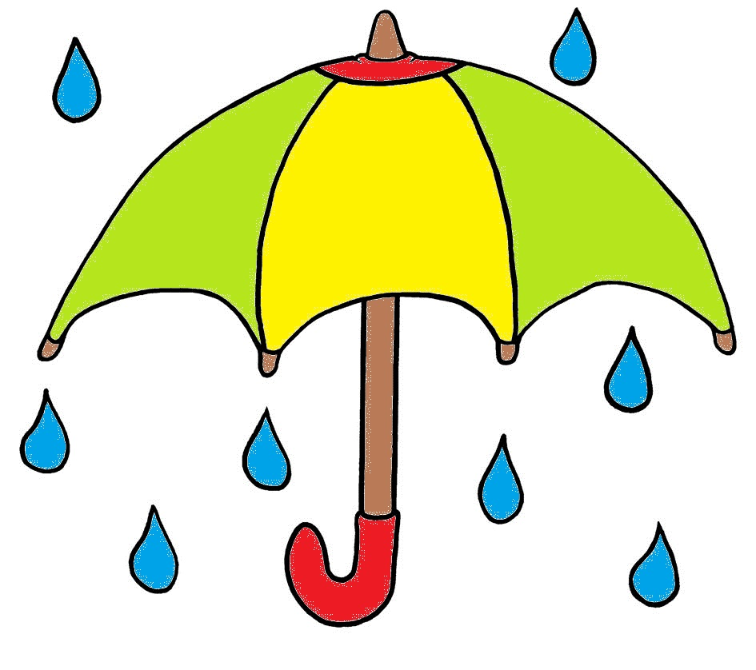 | Keep one hand steady and raise the other, as if raising an umbrella, and say u, u, u, u.  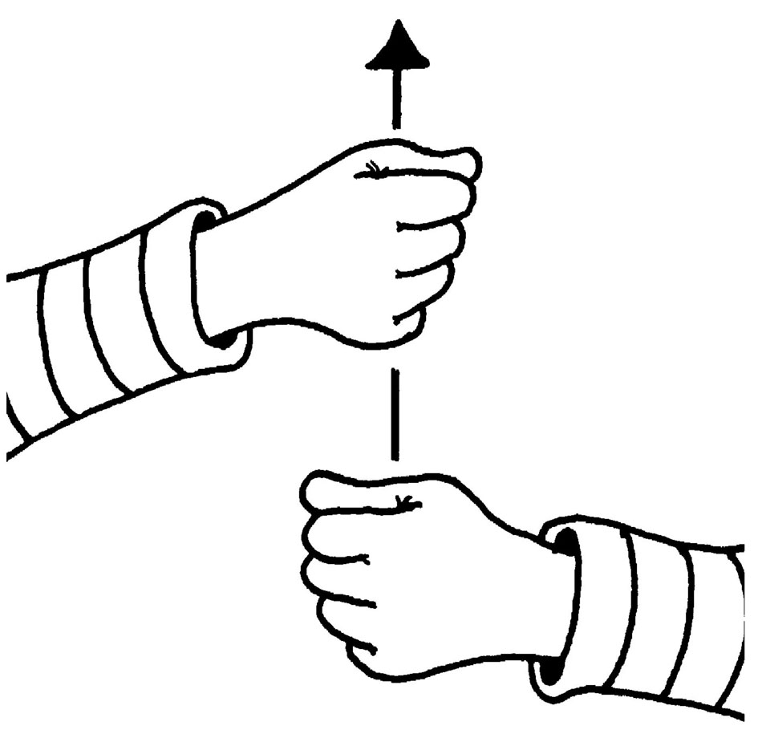 | (Tune: Skip to My Lou)  /u/-/u/ up go umbrellas.  /u/-/u/ up go umbrellas.  /u/-/u/ up go umbrellas...  ...when it starts to rain!

Letter Sound | Action | Song
l  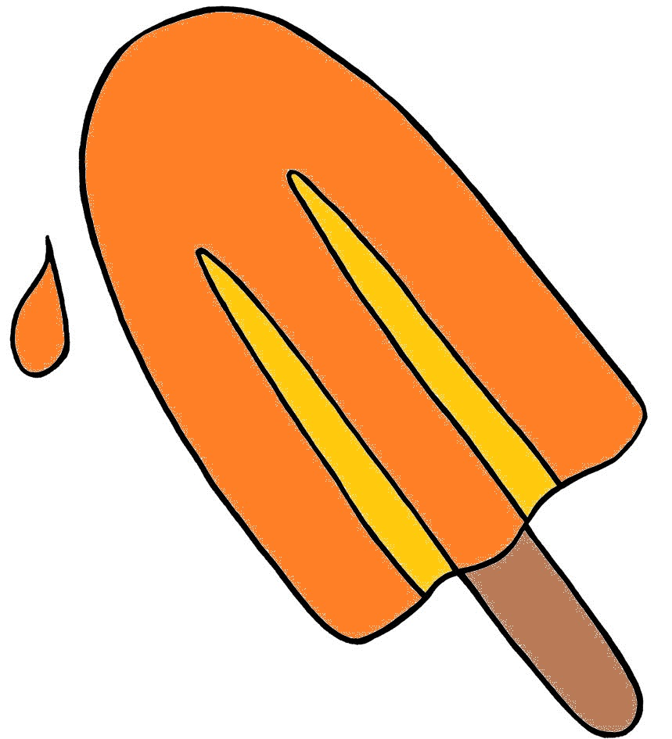 | Pretend to lick a lollipop and say l,l,l,l.  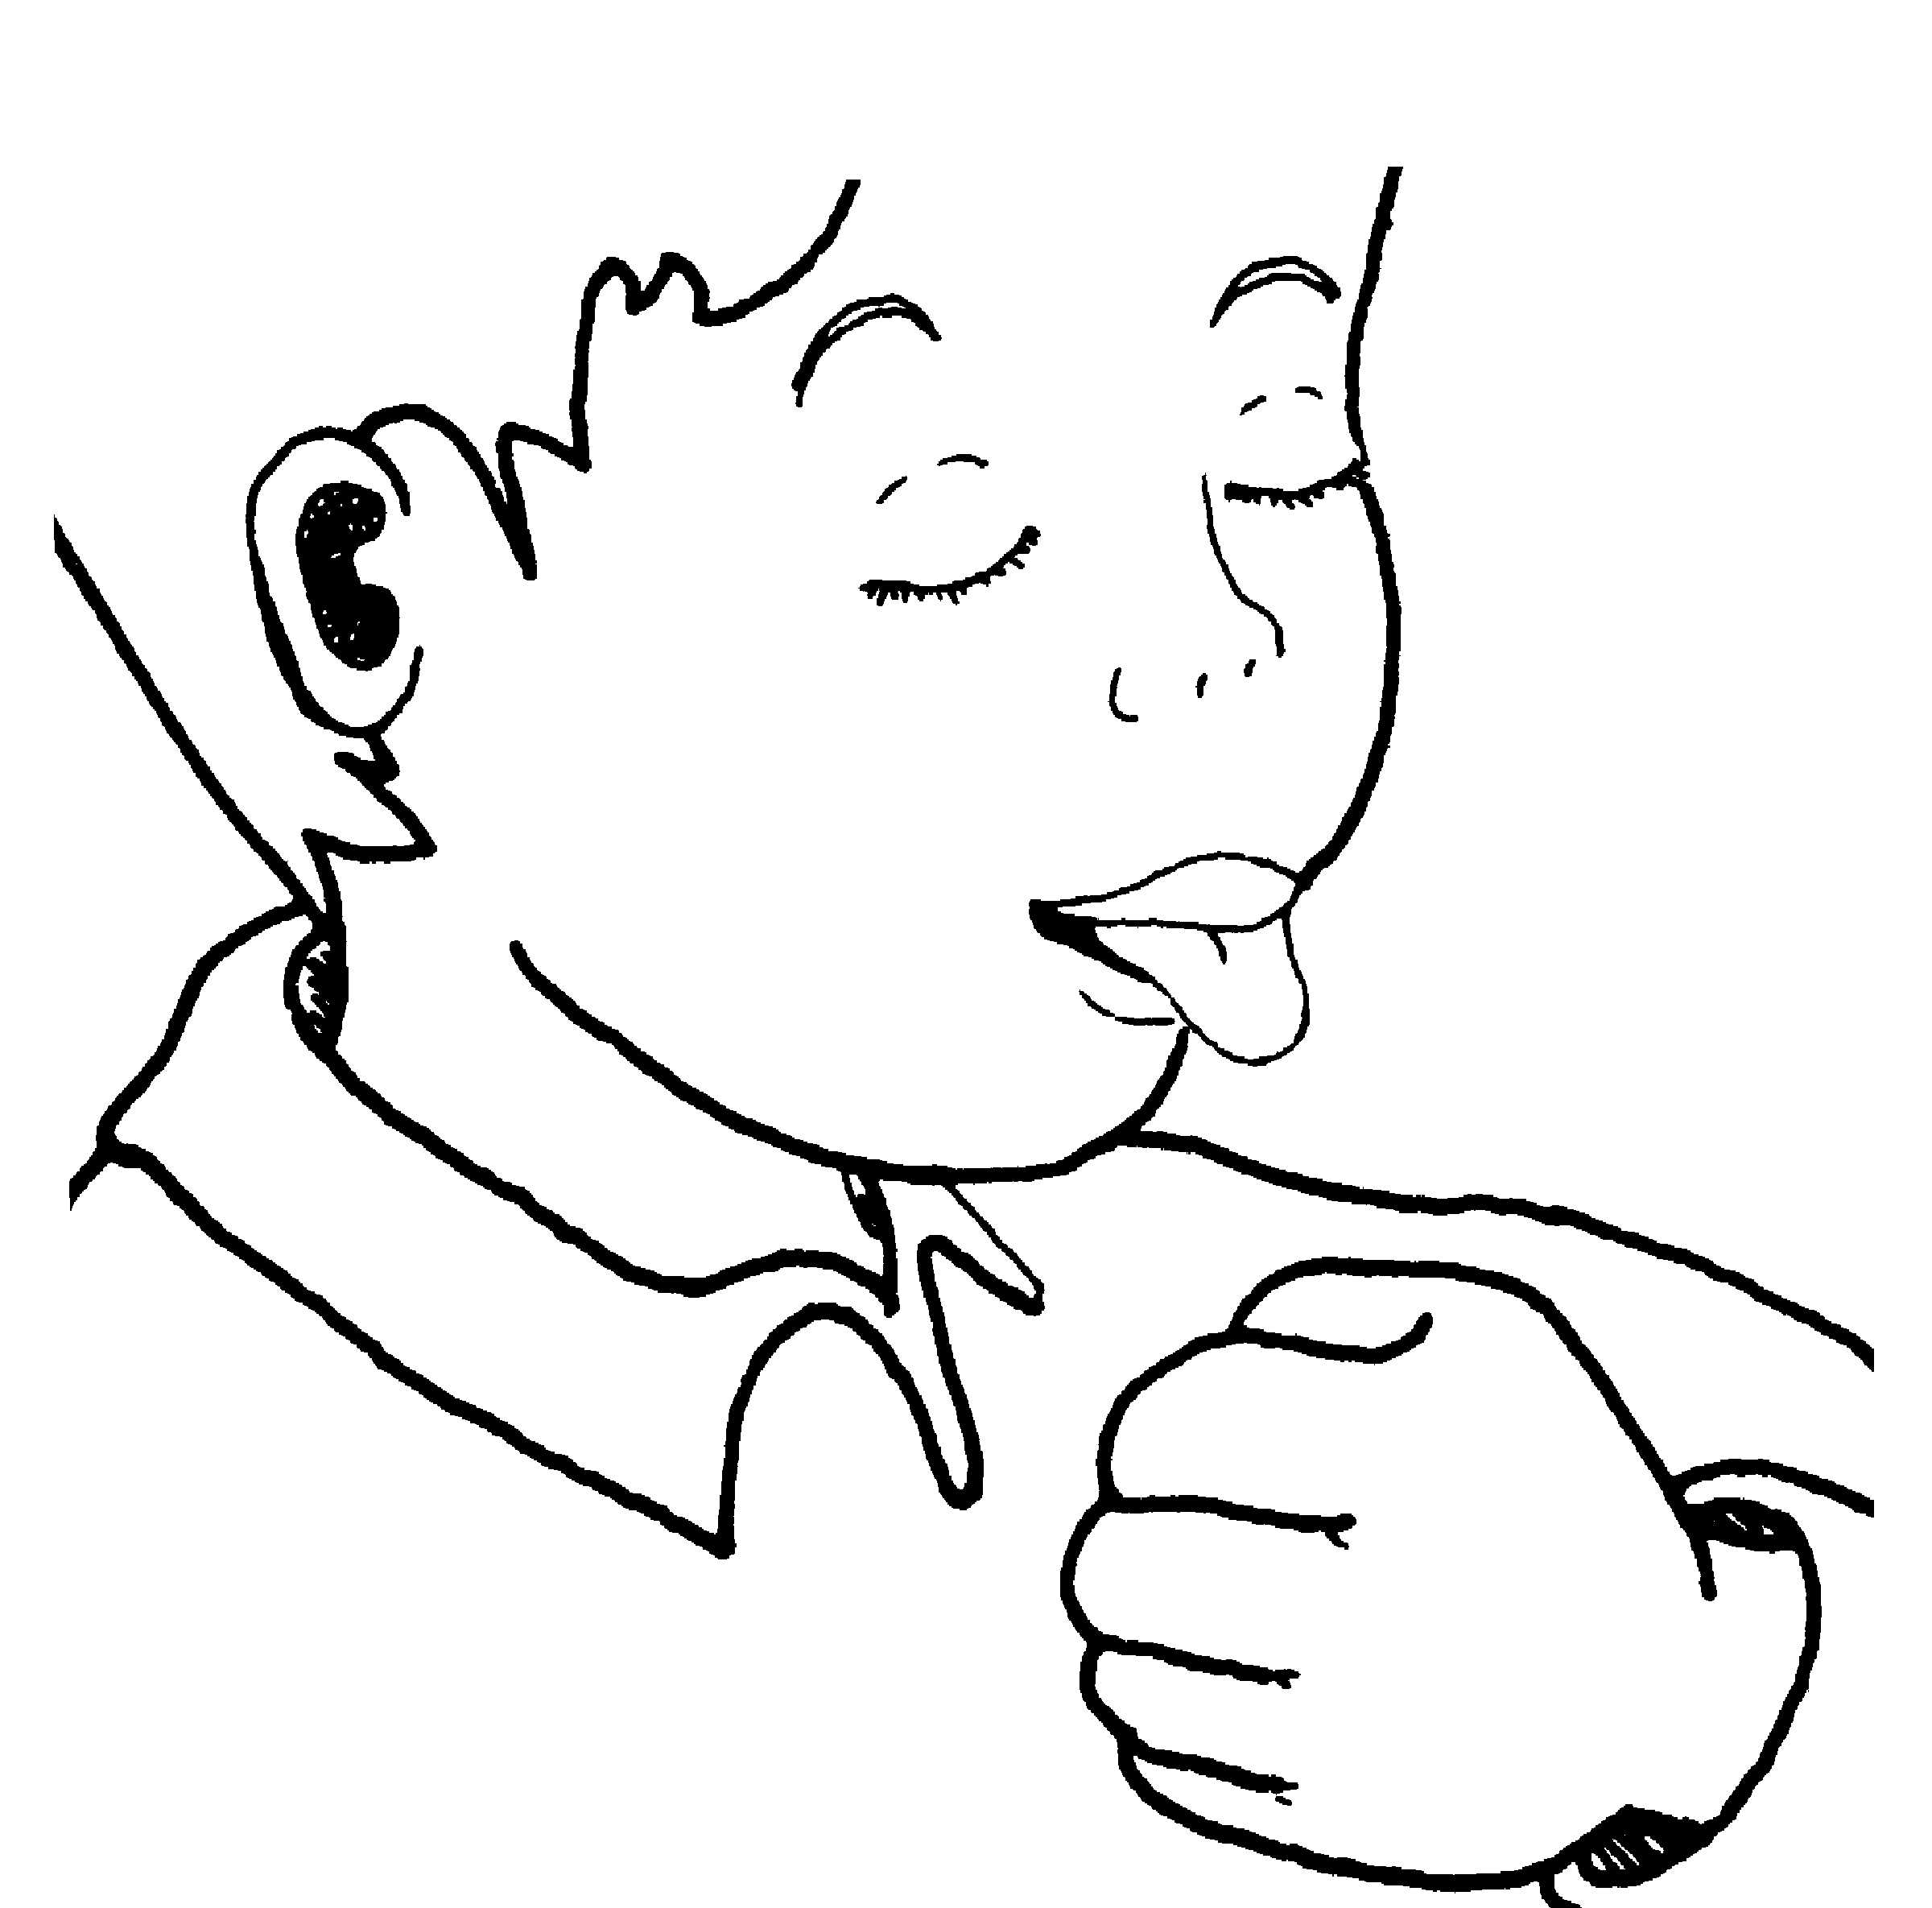 | (Tune: The Farmer in the Dell)  We lick our lollipops.  We lick our lollipops.  /l/-/l/-/l/-/l/!  We lick our lollipops.

Letter Sound | Action | Song
f  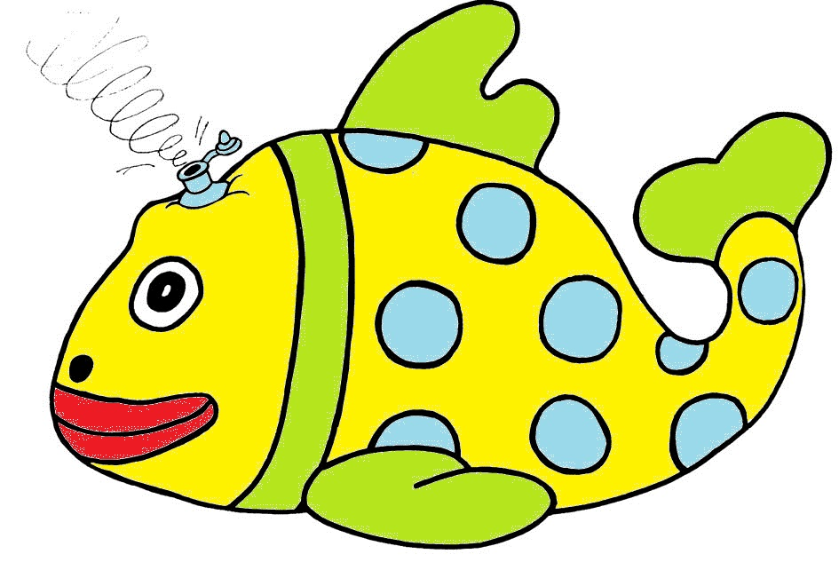 | Let your hands come together gently, as if an inflatable fish is deflating, and say f,f,f,f.  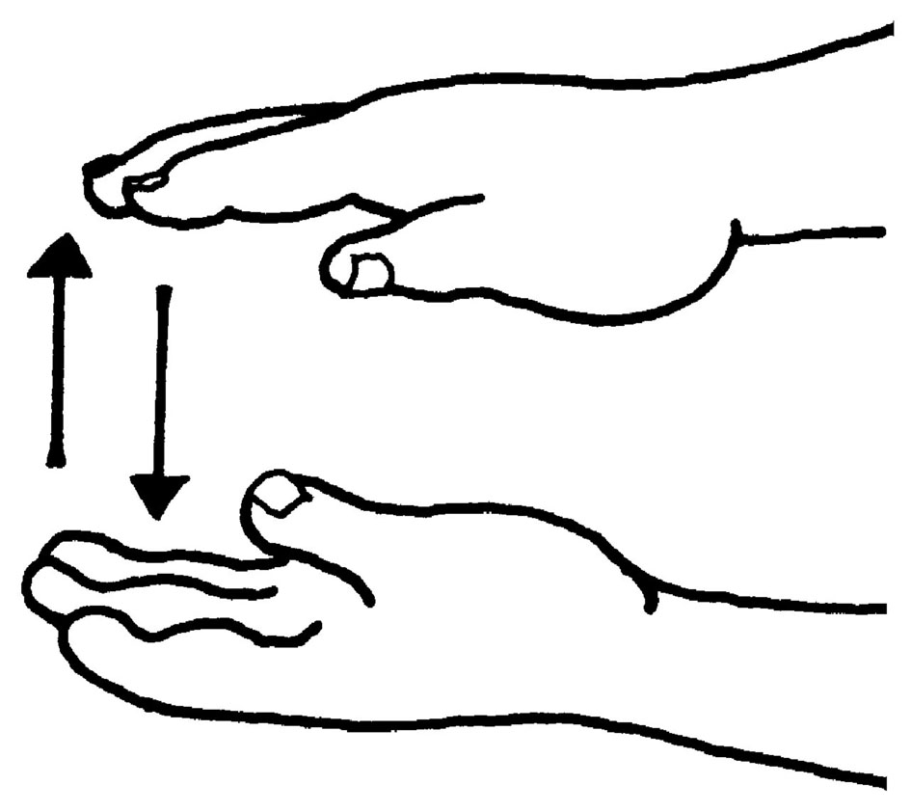 | (Tune: Old MacDonald)  My friends and I  went to the beach  with my floating fish.  It got a hole...  ...the air came out.  /ffff/!

Letter Sound | Action | Song
b  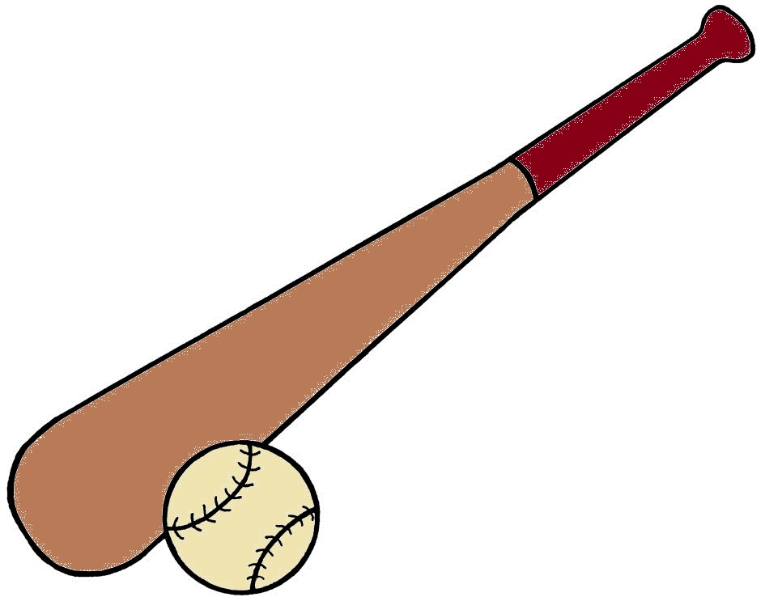 | Pretend to hit a ball with a bat, and say b,b,b,b.  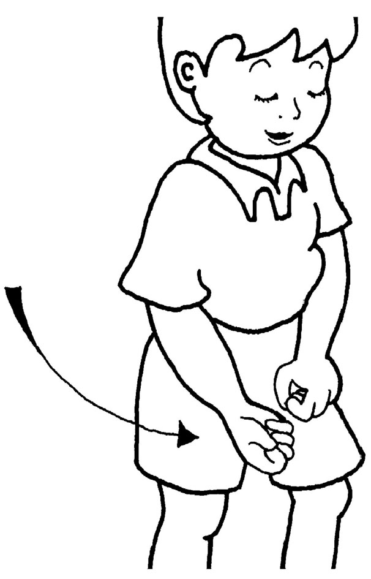 | (Tune: Camptown Races)  Bring your bat and bring your ball.  /b/!-/b/!  Bring your bat and bring your ball....  ...to the park to play!

