Letter Sound | Action | Song
ss  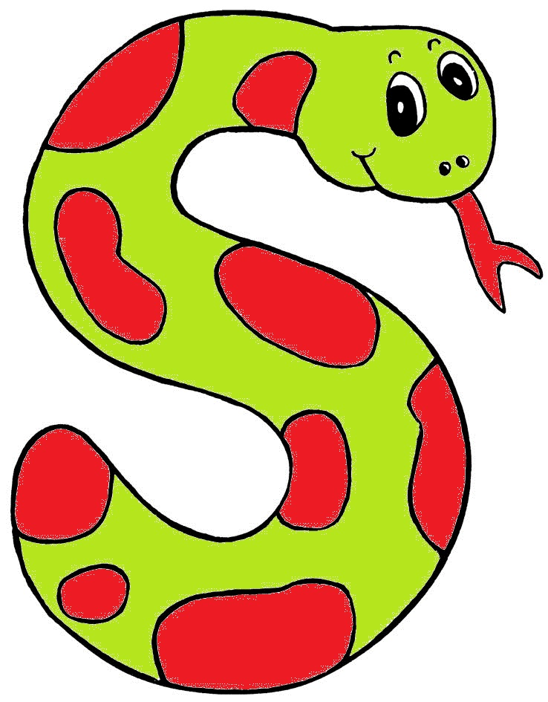 | Weave your hand  in an ‘s’ shape,  like a snake, and  say sssssssss.  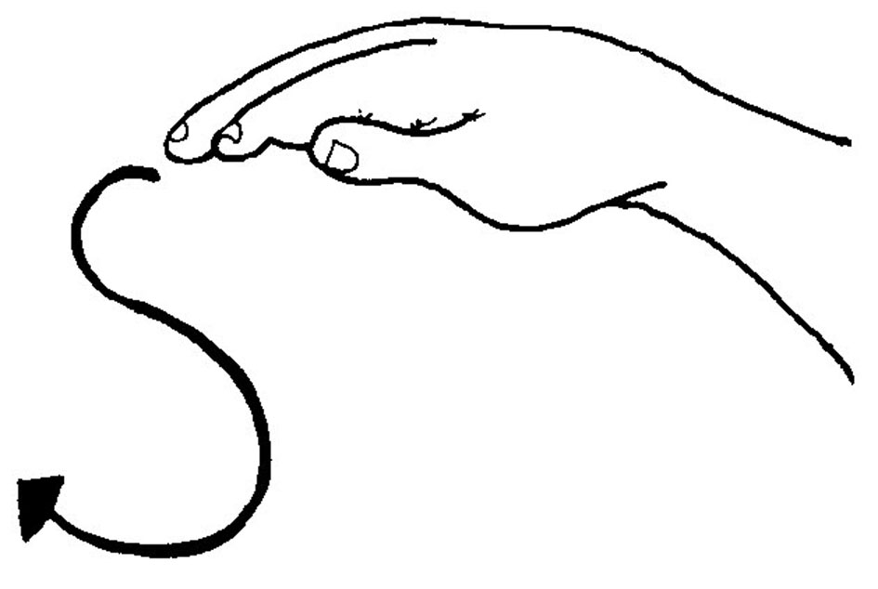 | (Tune: The Farmer in the Dell)  Then snake is in the grass  The snake is in the grass  /sss/! /sss/!  The snake is in the grass

Letter Sound | Action | Song
ll  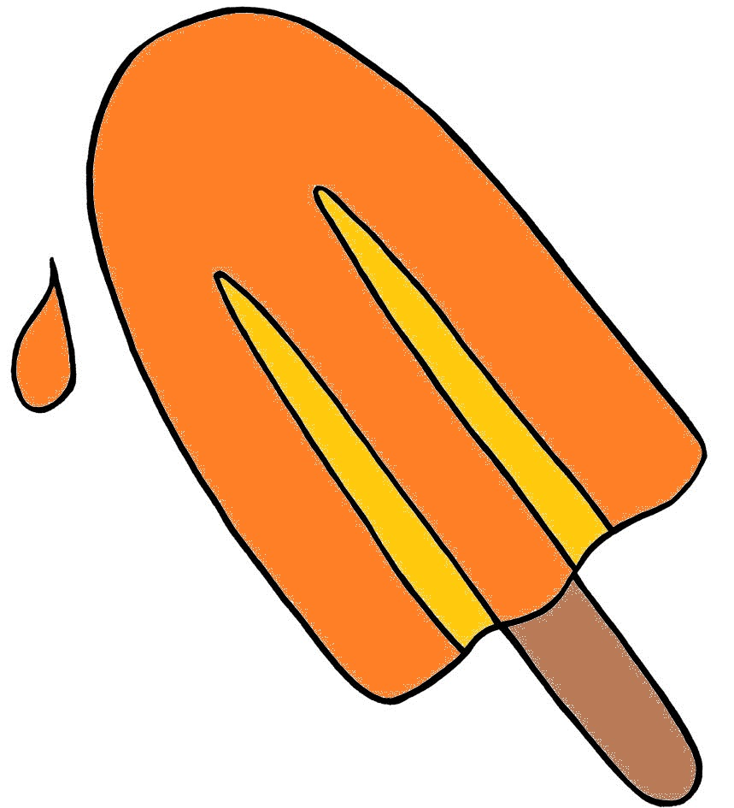 | Pretend to lick a lollipop and say l,l,l,l.  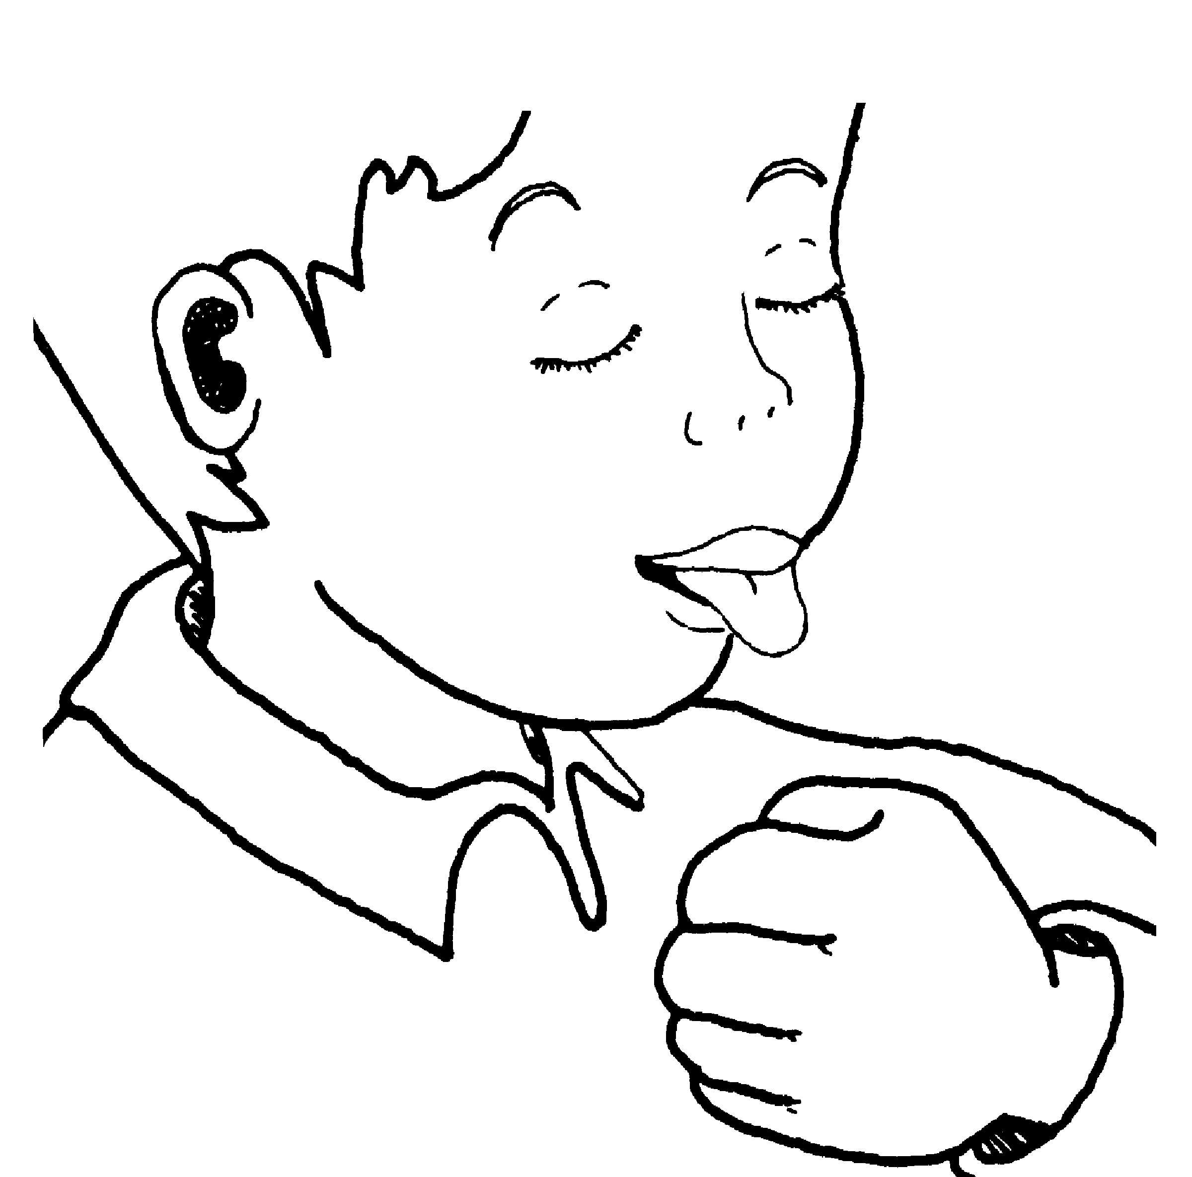 | (Tune: The Farmer in the Dell)  We lick our lollipops.  We lick our lollipops.  /l/-/l/-/l/-/l/!  We lick our lollipops.

Letter Sound | Action | Song
ff  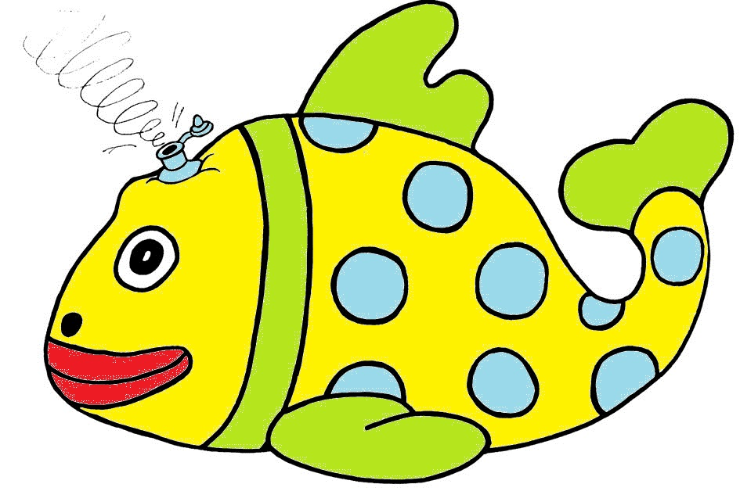 | 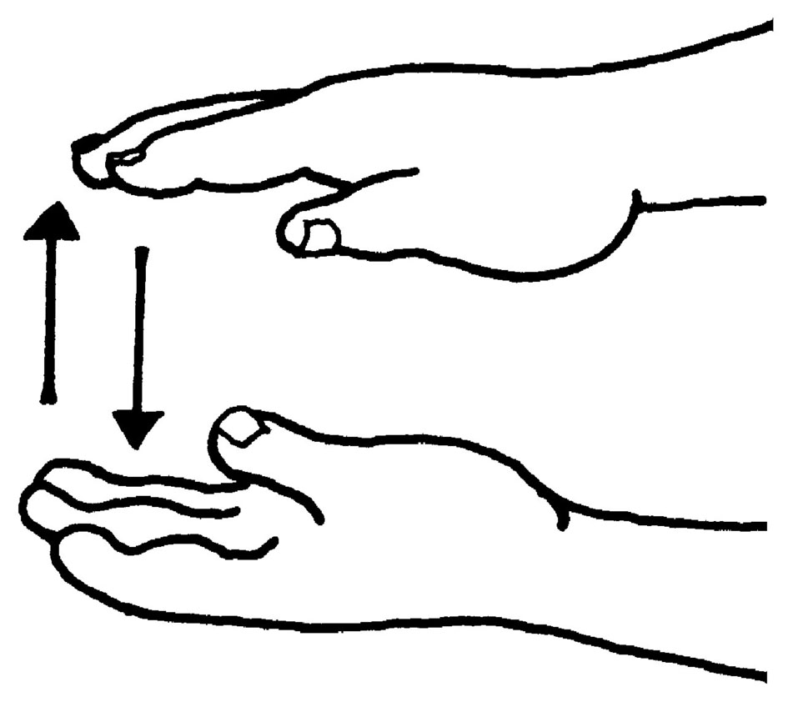  Let your hands come together gently, as if an inflatable fish is deflating, and say f,f,f,f. | (Tune: Old MacDonald)  My friends and I  went to the beach  with my floating fish.  It got a hole...  ...the air came out.  /ffff/!

Double letters make one sound.

