Letter Sound | Action | Song
s  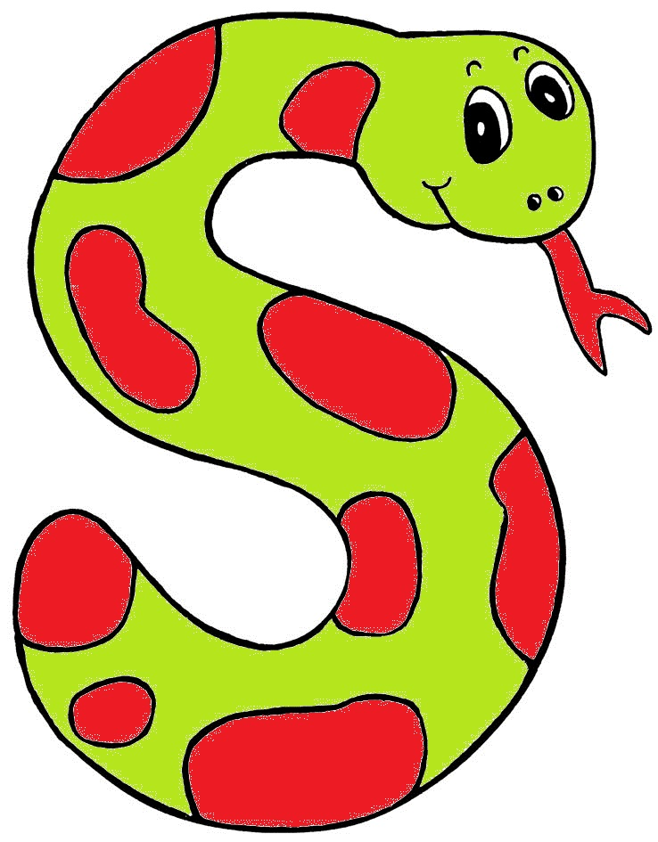 | Weave your hand  in an ‘s’ shape,  like a snake, and  say sssssssss.  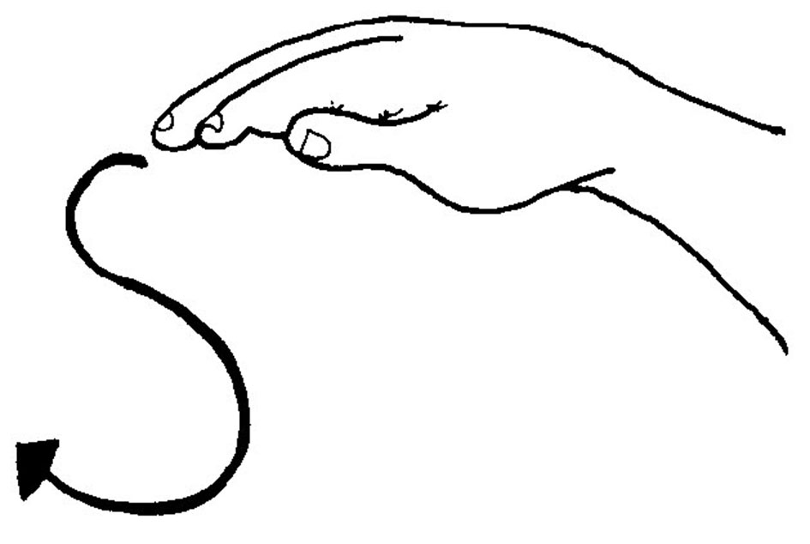 | (Tune: The Farmer in the Dell)  Then snake is in the grass  The snake is in the grass  /sss/! /sss/!  The snake is in the grass

Letter Sound | Action | Song
a  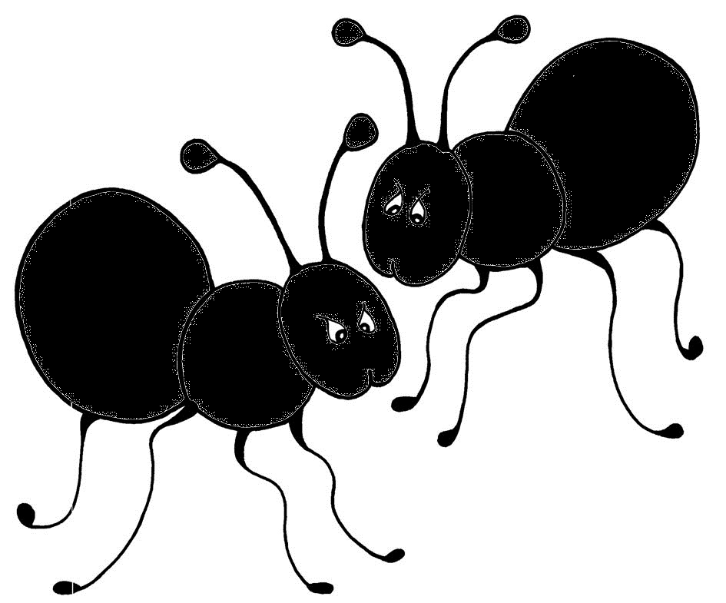 | Wiggle your fingers above the elbow, as if ants are crawling on you and say a,a,a,a,a,!  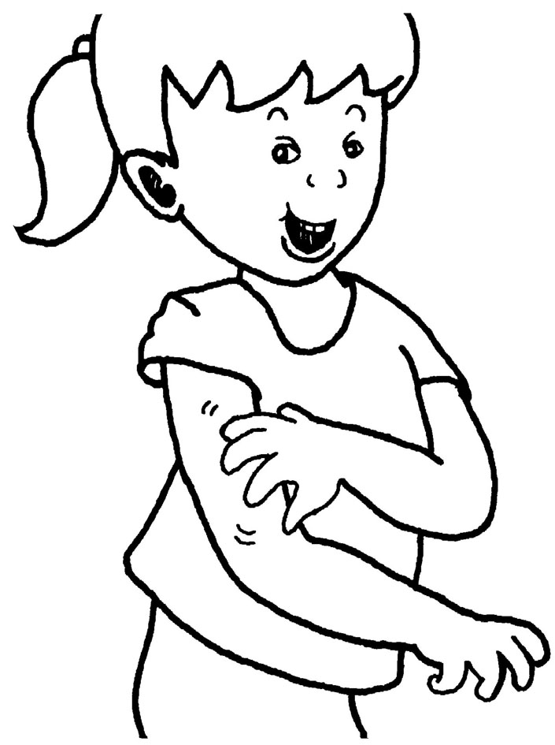 | (Tune: Skip to My Lou)  /a/-/a/! Ants on my arm  /a/-/a/! Ants on my arm  /a/-/a/! Ants on my arm  They’re causing me alarm

Letter Sound | Action | Song
t  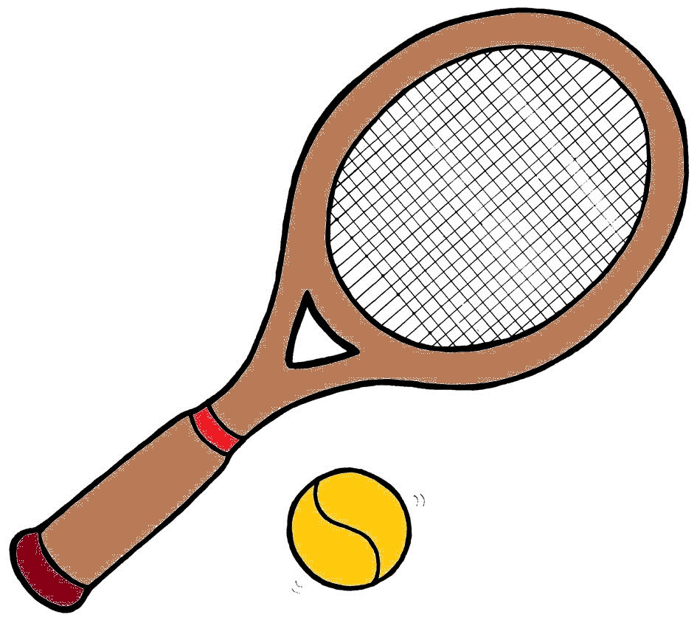 | Turn your head from side to side, as if you are watching tennis, and say tttttt.  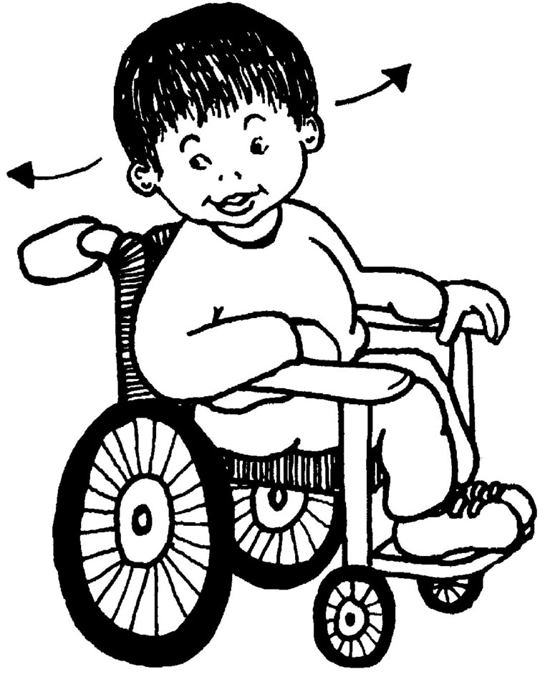 | (Tune: The Muffin Man)  When I watch the tennis game,  /t/-/t/-/t/,  /t/-/t/-/t/.....  ....when I watch the tennis game my head goes back and forth.

Letter Sound | Action | Song
n  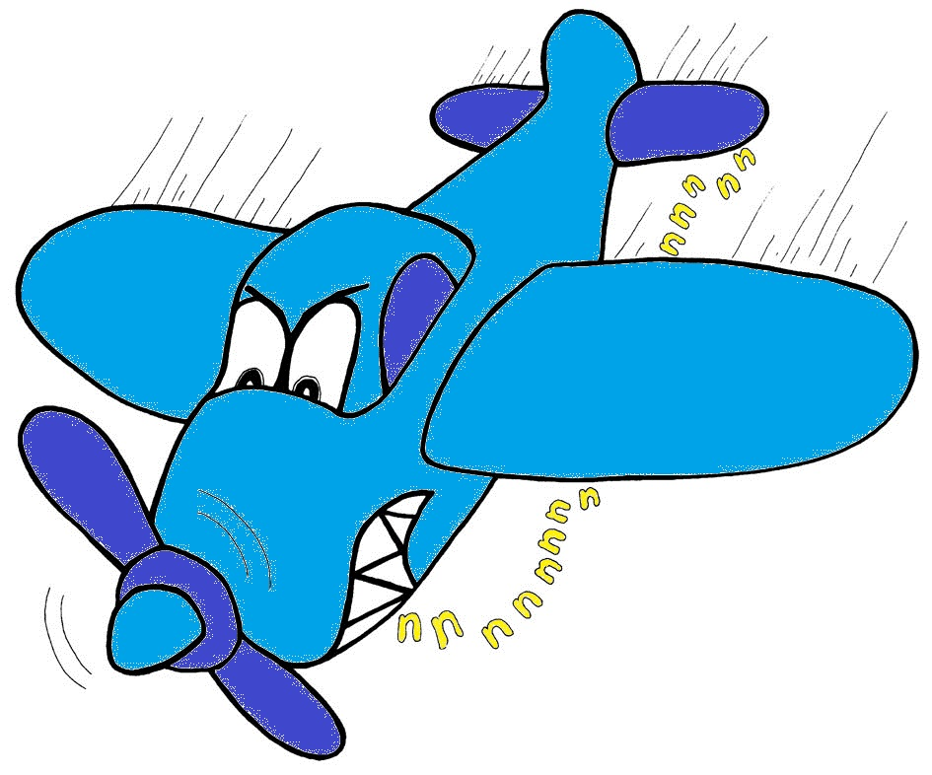 | Pretend to be a plane, with your arms out like wings, and say nnnnnn.  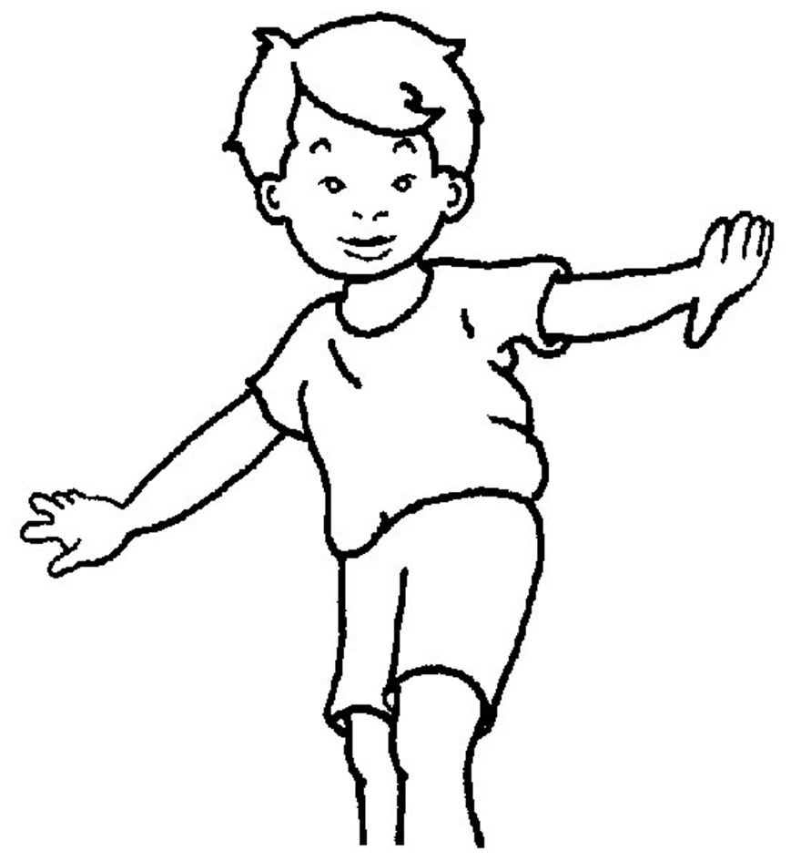 | (Tune: Skip to My Lou)  Hear the aerpoplane,  /nnn/!  Hear the aerpoplane,  /nnn/!  Hear the aerpoplane,  /nnn/!  ...making lots of noise.

