Letter Sound | Action | Song
qu  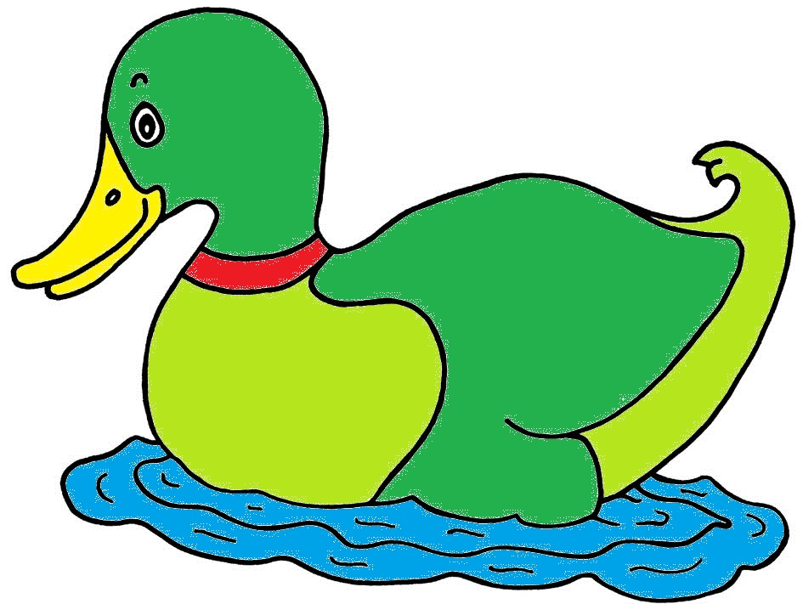 | Make a duck’s beak with your hands, and say qu, qu, qu.  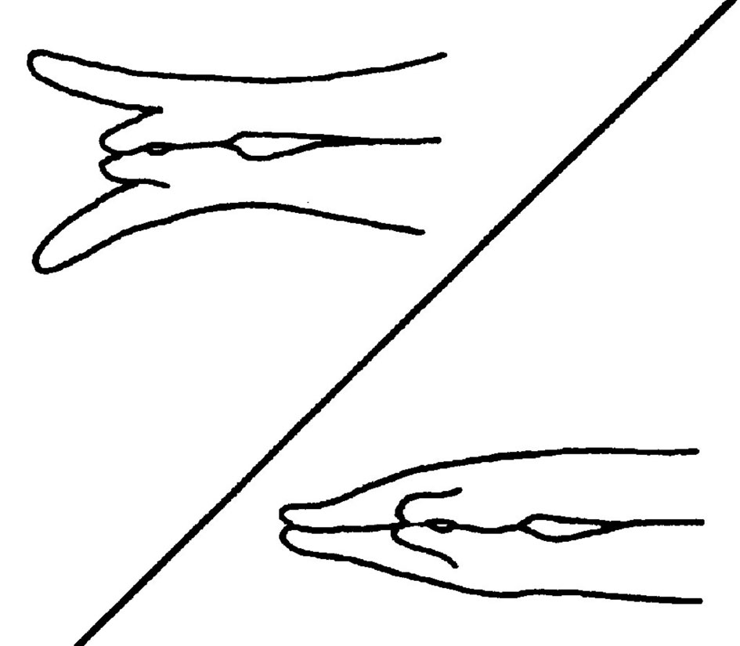 | (Tune: The Wheels on the Bus)  The duck in the pond  quacks, “/qu/-/qu/-/qu/,”  “/qu/-/qu/-/qu/,”  “/qu/-/qu/-/qu/,”  The duck in the pond  quacks, “/qu/-/qu/-/qu/,”  all around the pond.

quit
quilt
quick
quack
squid
quiz

