Letter Sound | Action | Song
oa  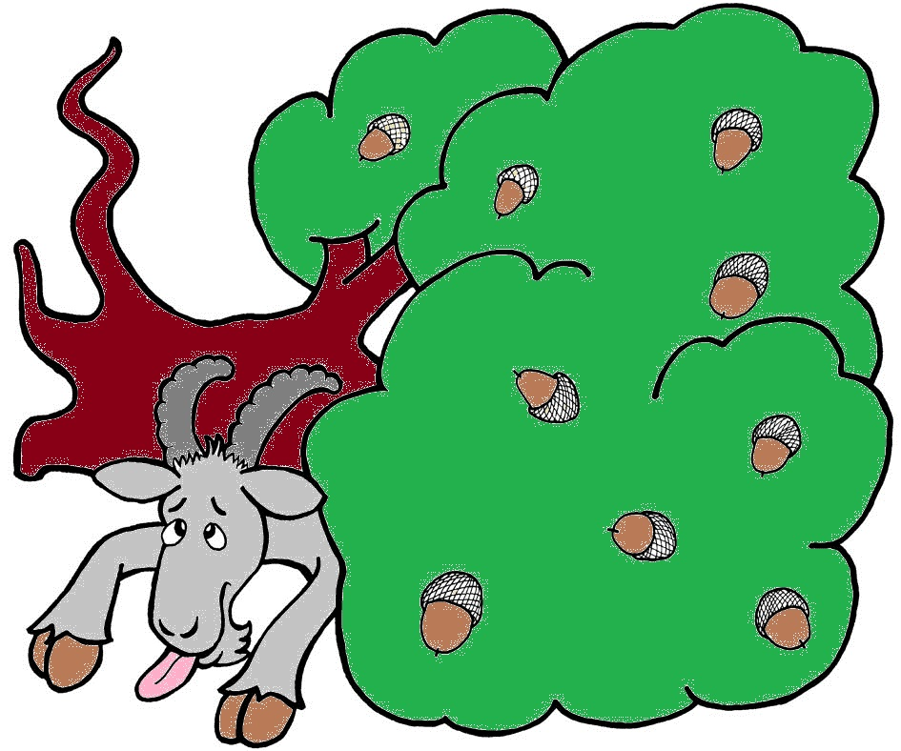 | Bring a hand over your mouth, as if something has gone wrong, and say oh!  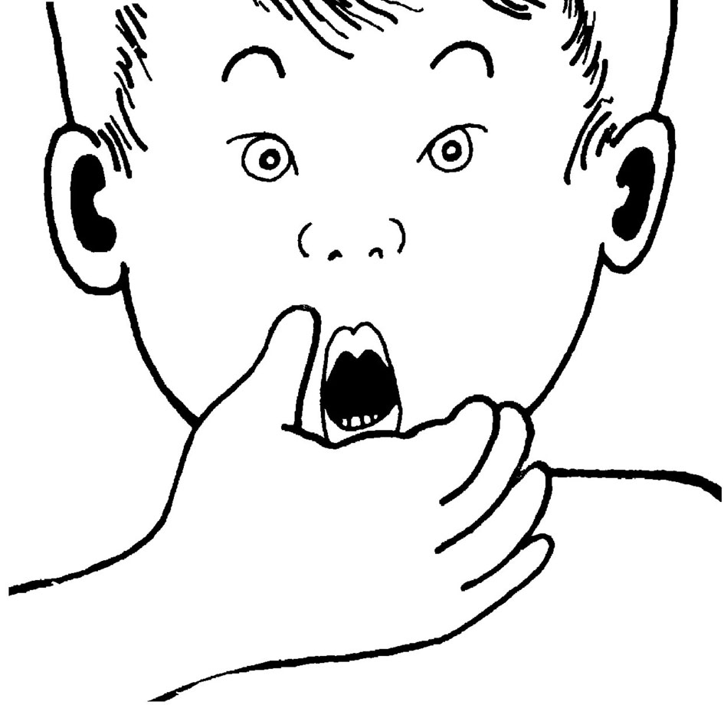 | (Tune: The Muffin Man)  Oh, did you see  The billy goat?  /oa/-/oa/-/oa/,  /oa/-/oa/-/oa/.  Oh, did you see  The billy goat?  /oa/-/oa/-/oa/,  Under the ols oak tree?

coat
goat
boat
soak
soap
float

