Letter Sound | Action |  | Song
ng  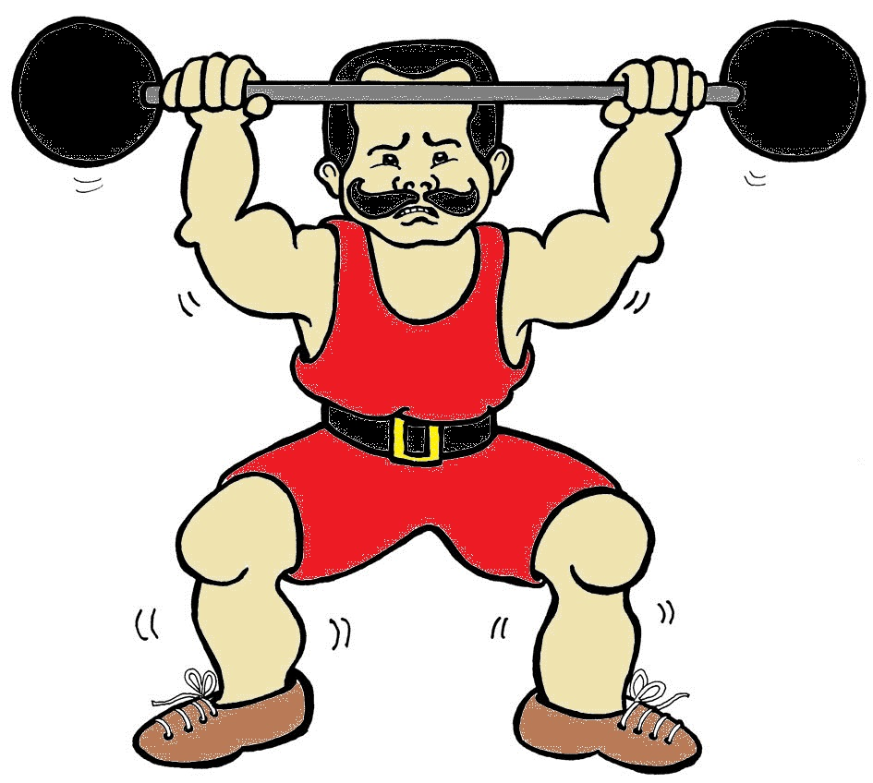 | Imagine you are a weightlifter and pretend to lift a heavy weight above your head saying ng.   |  | (Tune: If you are happy and you know it?  If you’re strong and you know it, say “/ng/!”  If you’re strong and you know it, say “/ng/!”  If you’re strong and you know it  And you really want to show it...  If you’re strong and you know it, say “/ng/!”
ring  sing  wing  thing bring |  | rang  sang  bang  fang  strong

