Letter Sound | Action | Song
j  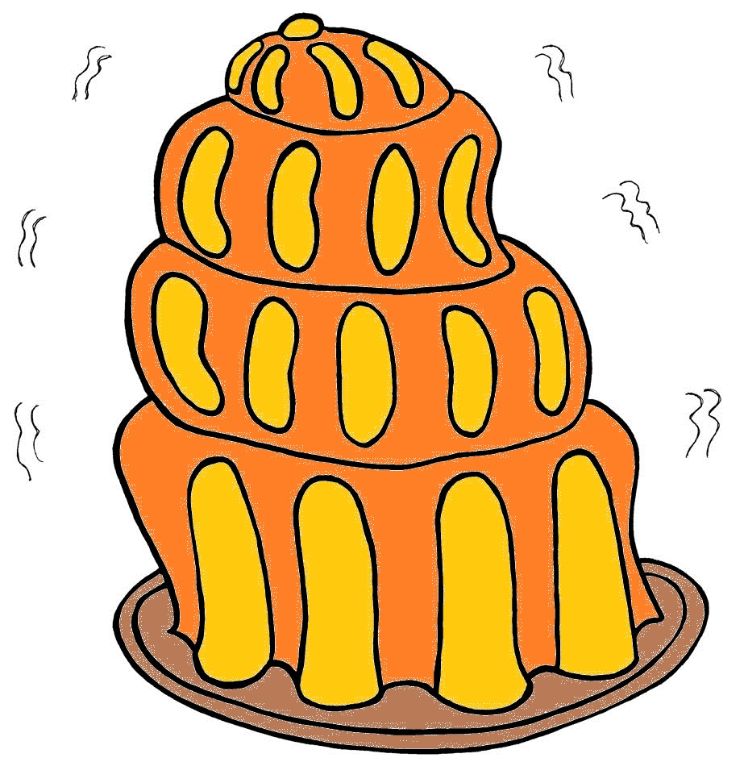 | Pretend to wobble on a plate, and say j,j,j,j.  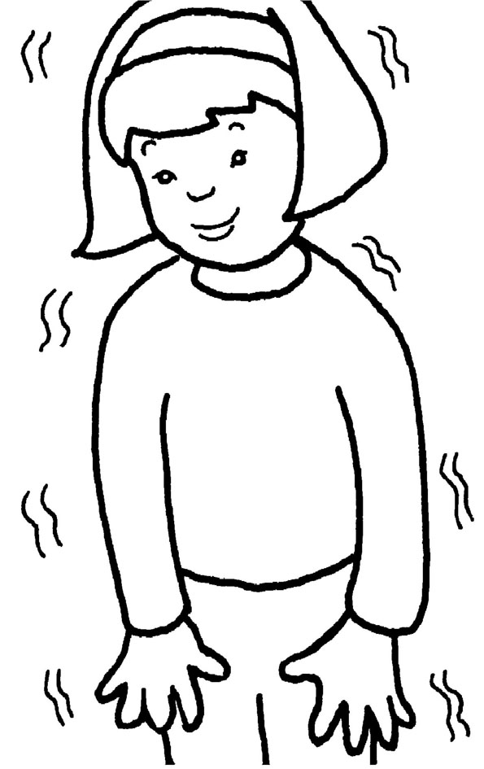 | (Tune: Jingle Bells)  Jelly and jam,  Jelly and jam,  Jiggling on the plate.  Oh, what will I eat with it?  /j/-/j/-/j/-/j/-/j/

Letter Sound | Action | Song
v  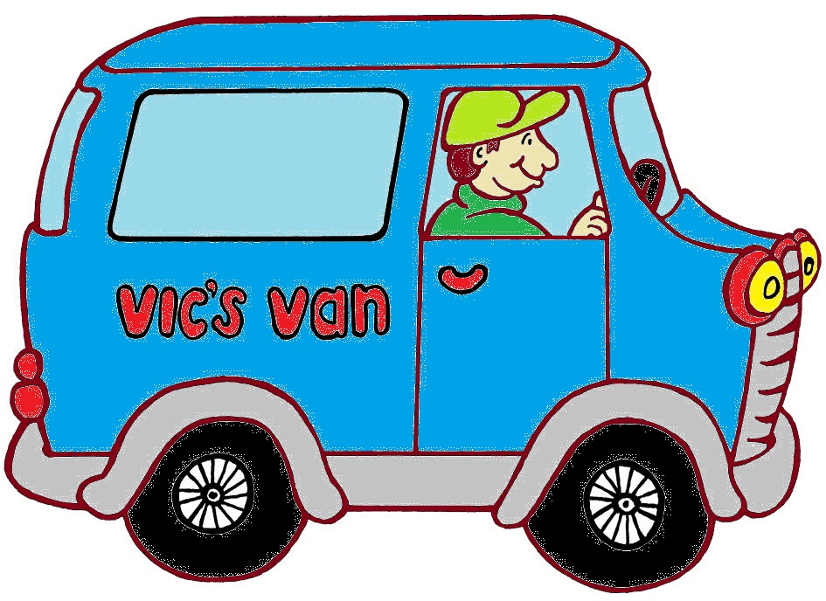 | Pretend to be driving along in a van, saying v,v,v,v.  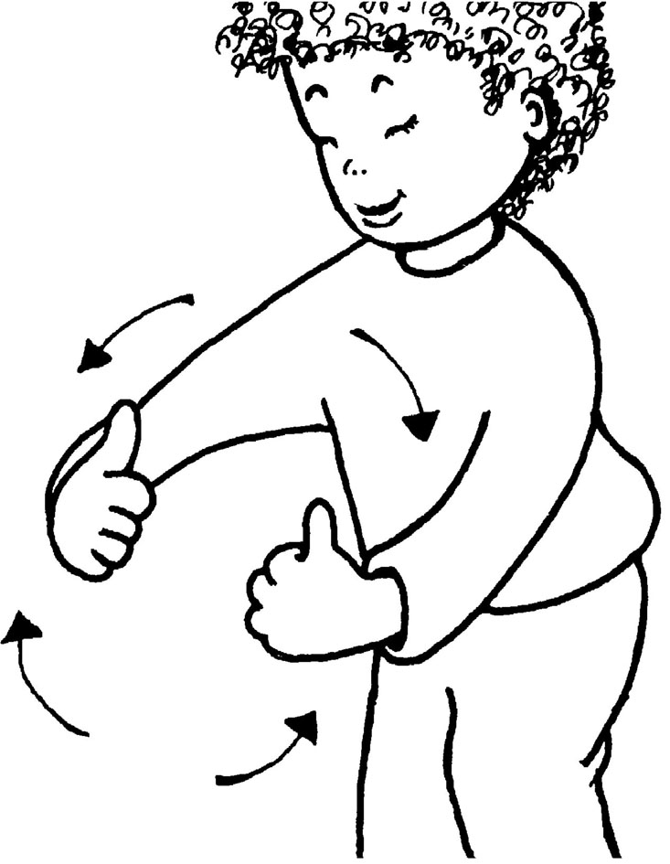 | (Tune: Go In and Out the Windows)  Drive Vic’s van  round the village.  Drive Vic’s van  round the village.  Drive Vic’s van  round the village.  /v/-/v/-/v/-/v/-/v/!

Letter Sound | Action | Song
w  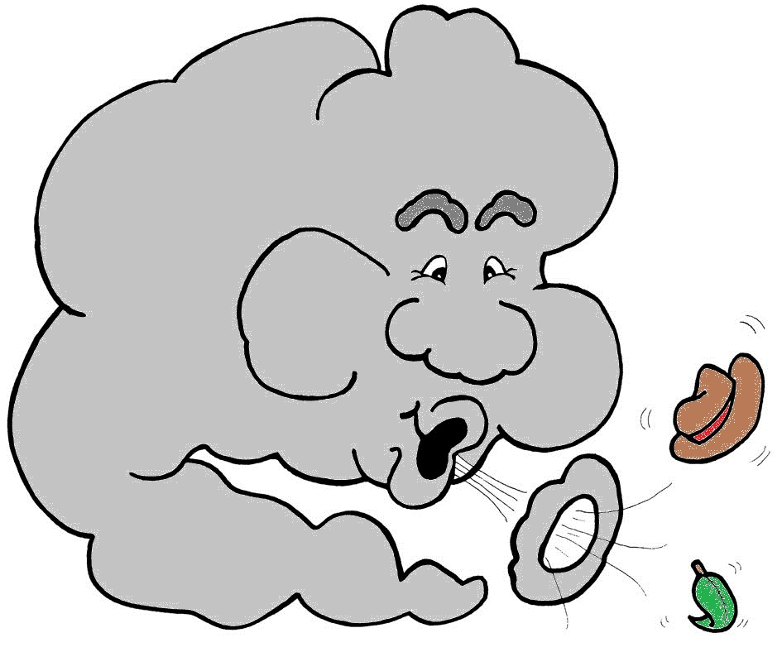 | Spiral your hand down, as if water is gurgling down a drain, and say g,g,g,g.  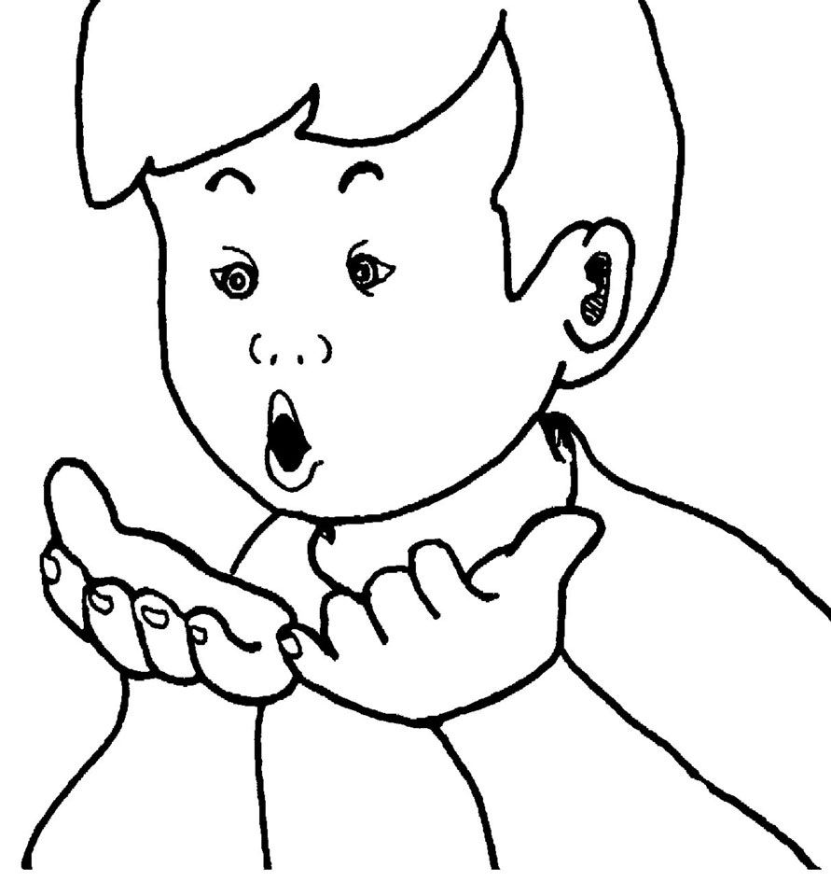 | (Tune: He’s Got the Whole World in His Hands)  I see the clouds moving,  /w/-/w/-/w/.  I see the kites flying,  /w/-/w/-/w/.  I see the trees bending,  /w/-/w/-/w/.  The wind is blowing strong!

Letter Sound | Action | Song
x  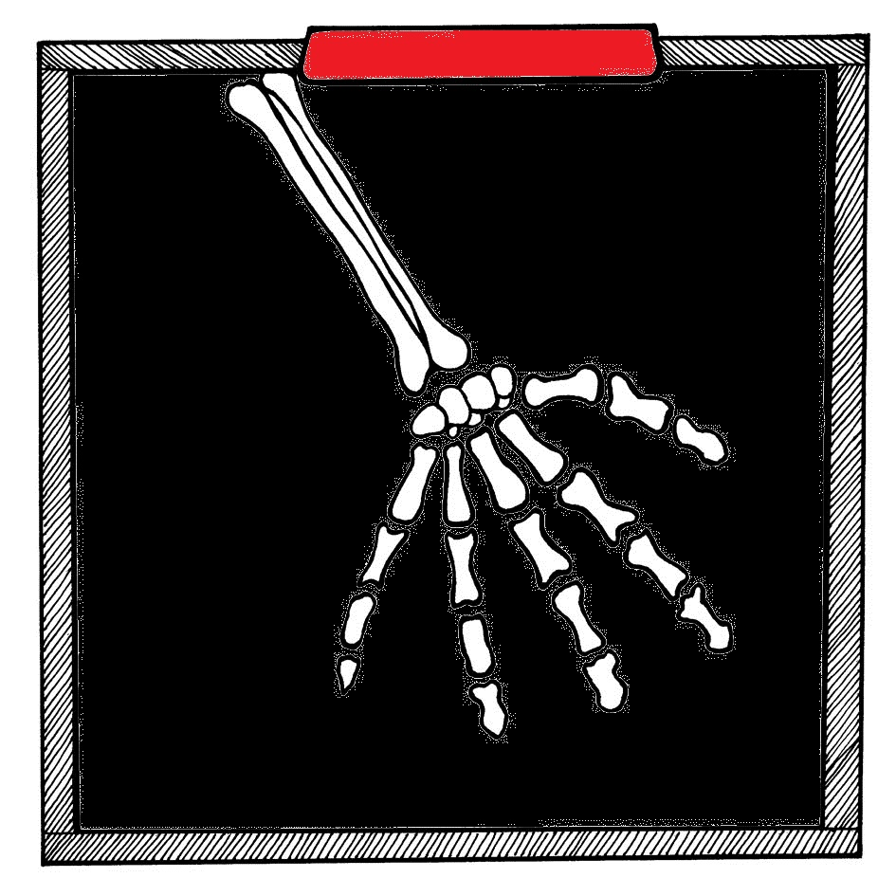 | Pretend to take an x-ray with an x-ray camera, saying ks, ks, ks, ks.  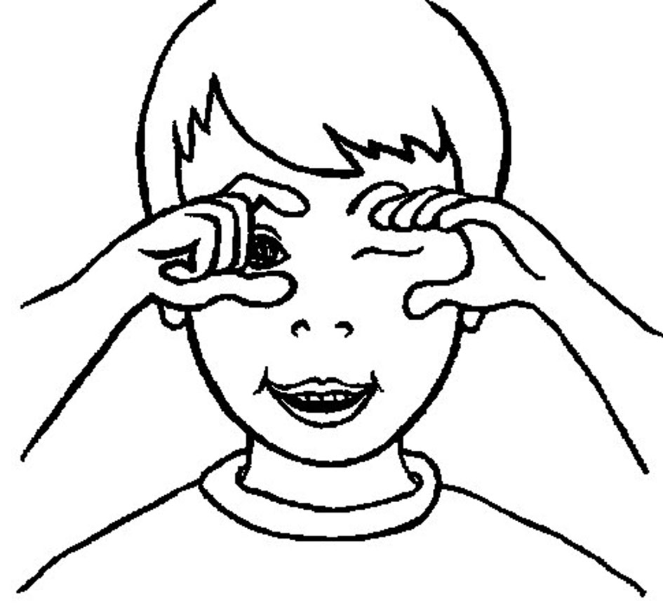 | (Tune: Skip to My Lou)  /ks/-/ks/! Take an x-ray.  /ks/-/ks/! Take an x-ray.  /ks/-/ks/! Take an x-ray.  - X-ray of my hand!

