Letter Sound | Action | Song
i  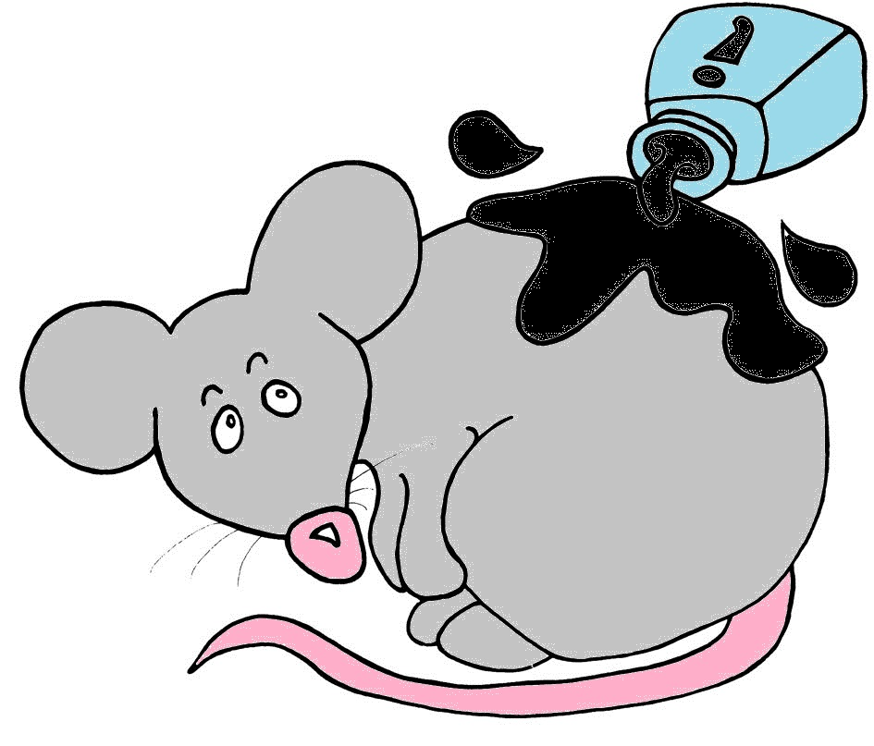 | Pretend to be a mouse by wiggling your fingers at the end of your nose, like whiskers, and squeak i,i,i  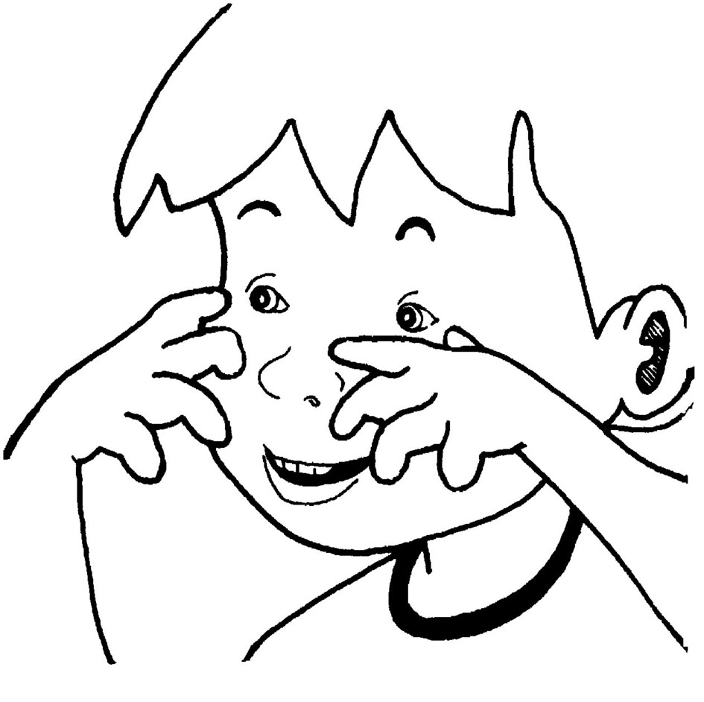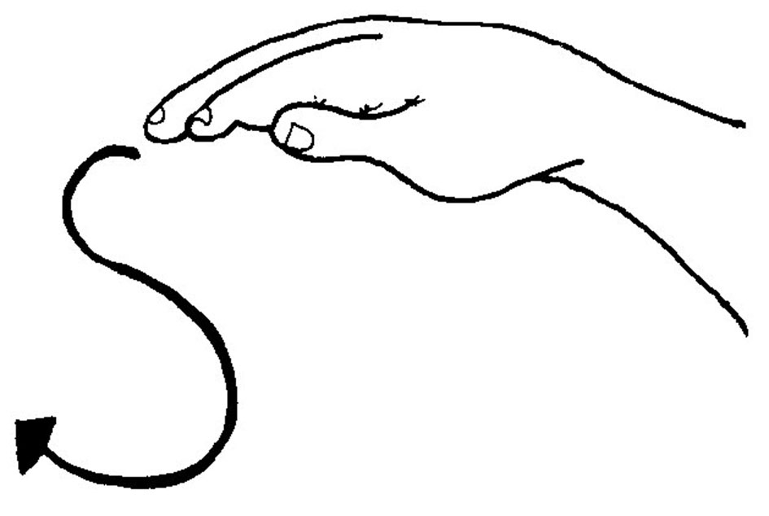 | (Tune: Hickory Dickory Dock)  Inky the mouse is my pet.  She spilled the ink and got wet.  The ink it spread  all over the desk.  /i/-/i/-/i/-/i/  - Inky’s wet!

Letter Sound | Action | Song
p  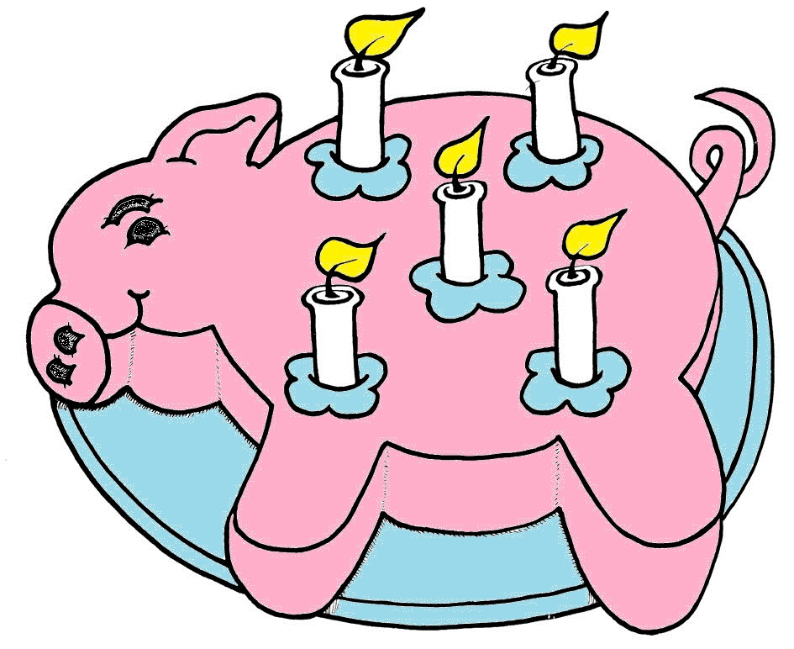 | Hold up your finger, as if it is a candle, and pretend to puff it out, saying p, p, p, p  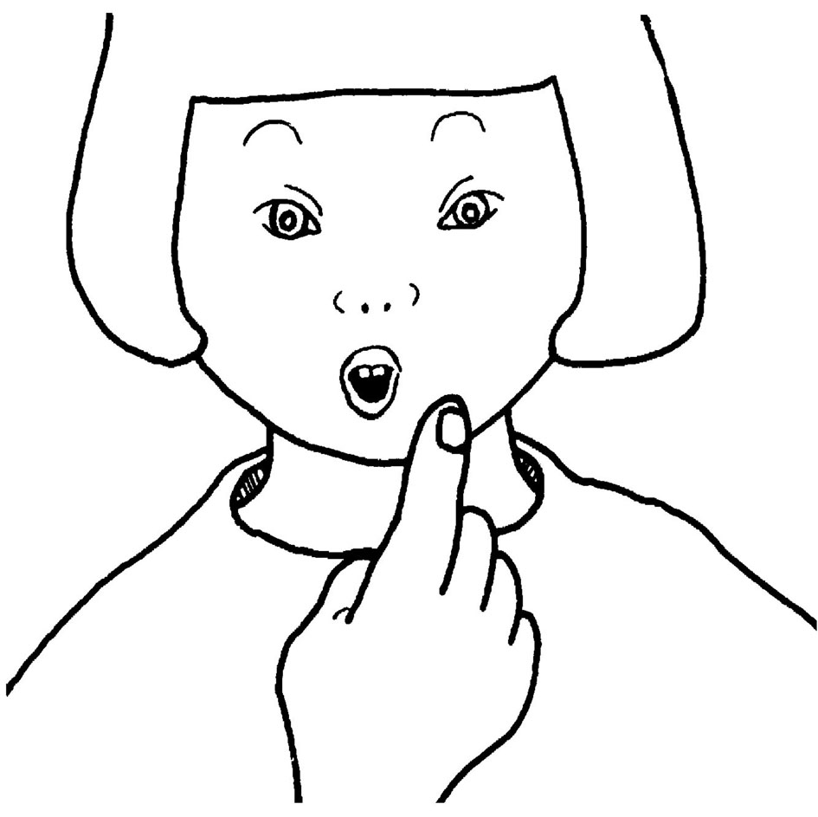 | (Tune: The Wheels on the Bus)  Puff out the candles  on the pink pig cake.  /p/-/p/-/p/,  /p/-/p/-/p/.  Puff out the candles  on the pink pig cake.  Puff! Puff! Puff!

Letter Sound | Action | Song
e  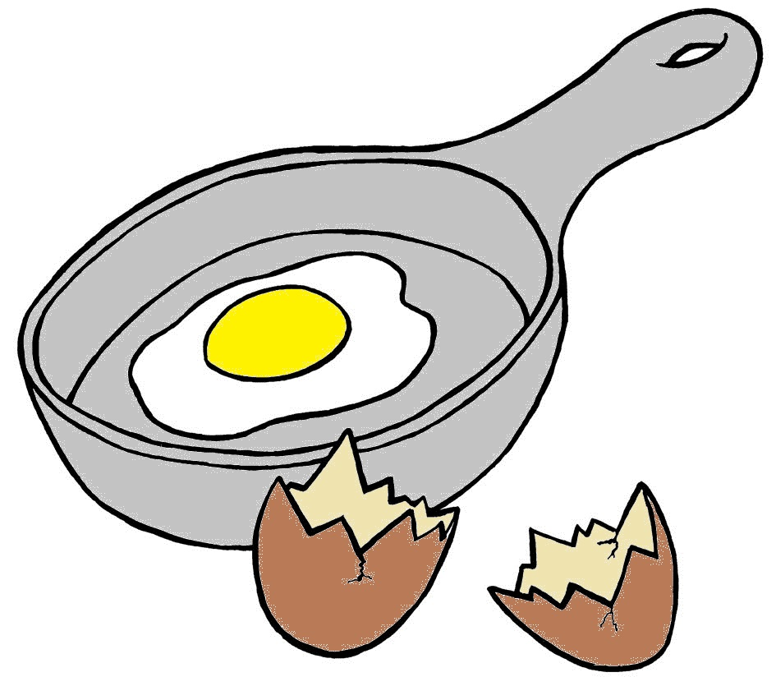 | Pretend to crack an egg against the side of a pan with one hand. Use both hands to open the shell, saying eh, eh, eh  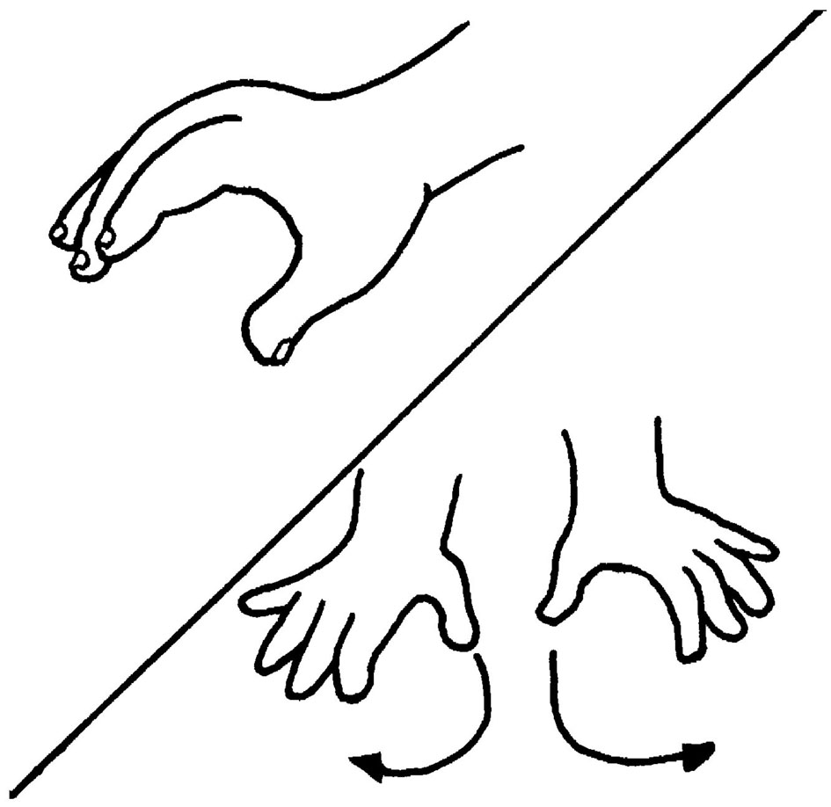 | (Tune: Skip to my Lou)  Eggs in the pan, /e/-/e/-/e/.  Eggs in the pan, /e/-/e/-/e/.  Eggs in the pan, /e/-/e/-/e/.  Crack the egg like this..../e/!

Letter Sound | Action | Song
d  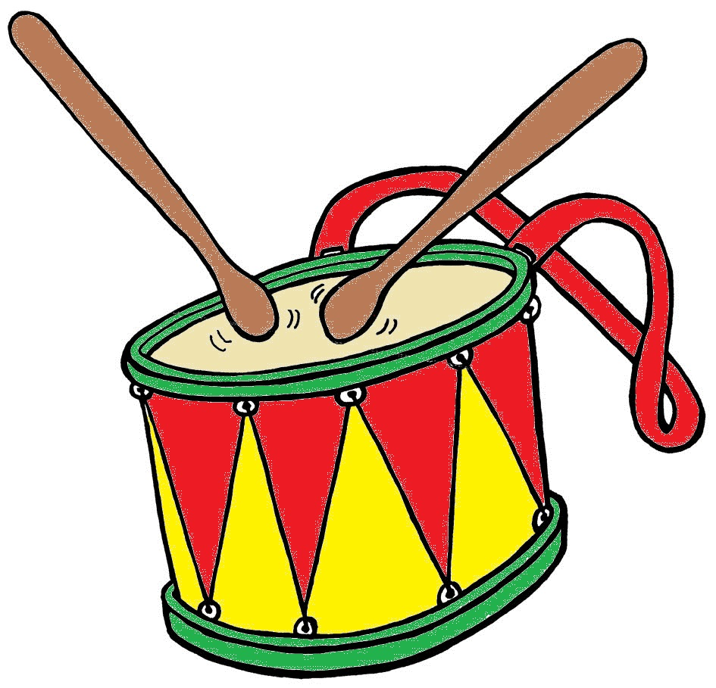 | Beat your hands up and down, as if you are playing a drum, and say d,d,d,d  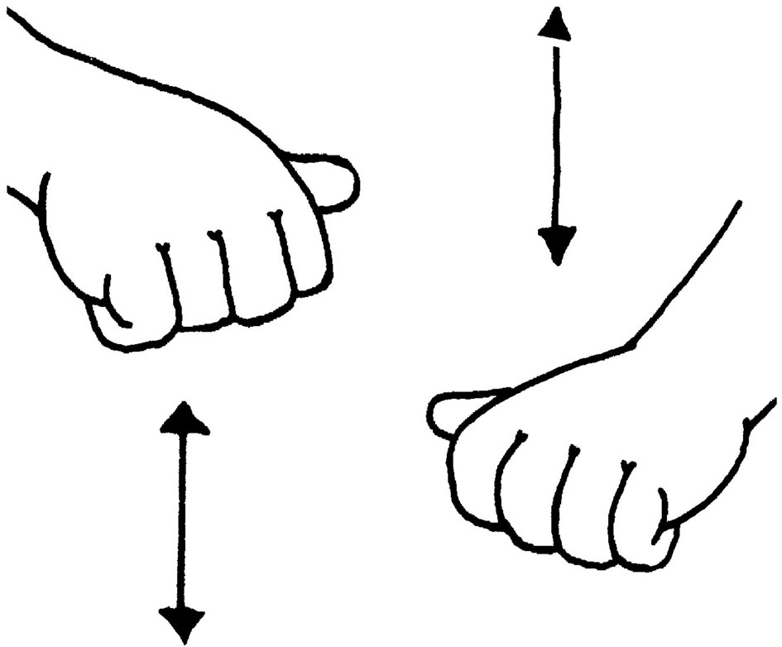 | (Tune: This Old Man)  See me play on my drum.  Playing drums is lots of fun,  With a /d/-/d/-/d/-/d/-/d/- /d/-/d/-/d/-/d/.  See me play on my drum.

