Letter Sound | Action | Song
h  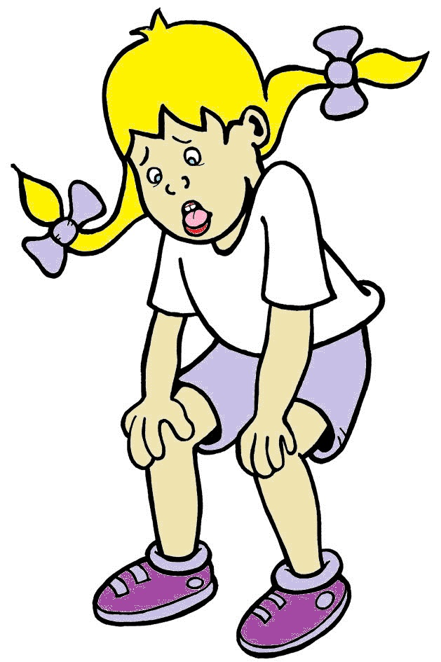 | Hold a hand up to your mouth, panting as if you are out of breath, and say h,h,h,h.  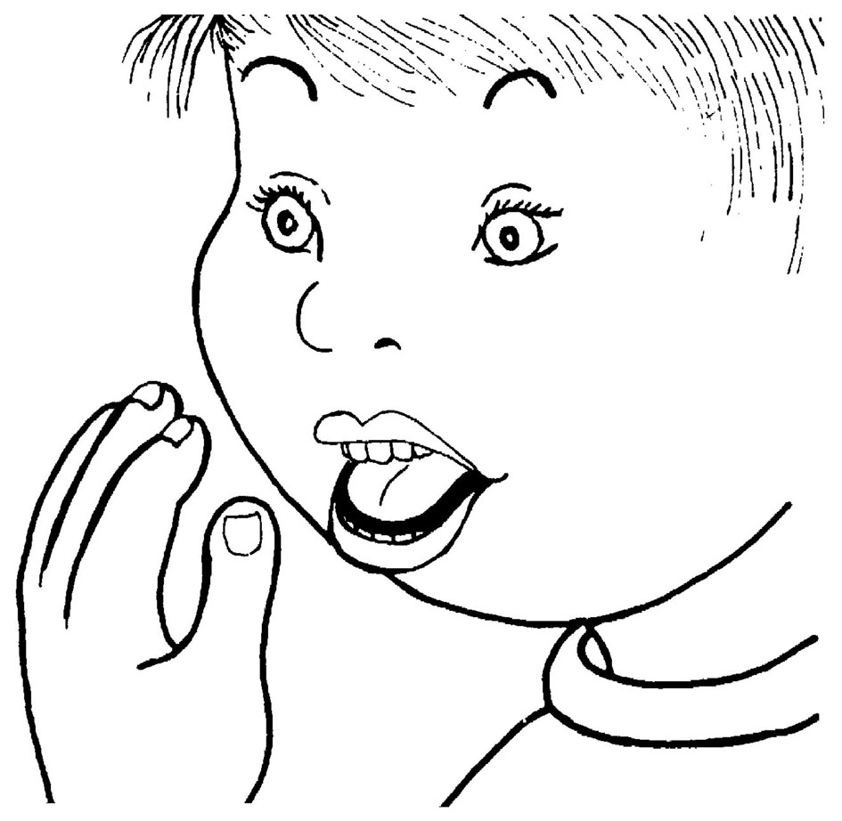 | (Tune: Apples and Bananas)  I like to hop, hop, hop, up  and down.  I like to hop, hop, hop, up  All around.  I like to hop, hop, hop, up  and down –  /h/-/h/-/h/-/h/!

Letter Sound | Action | Song
r  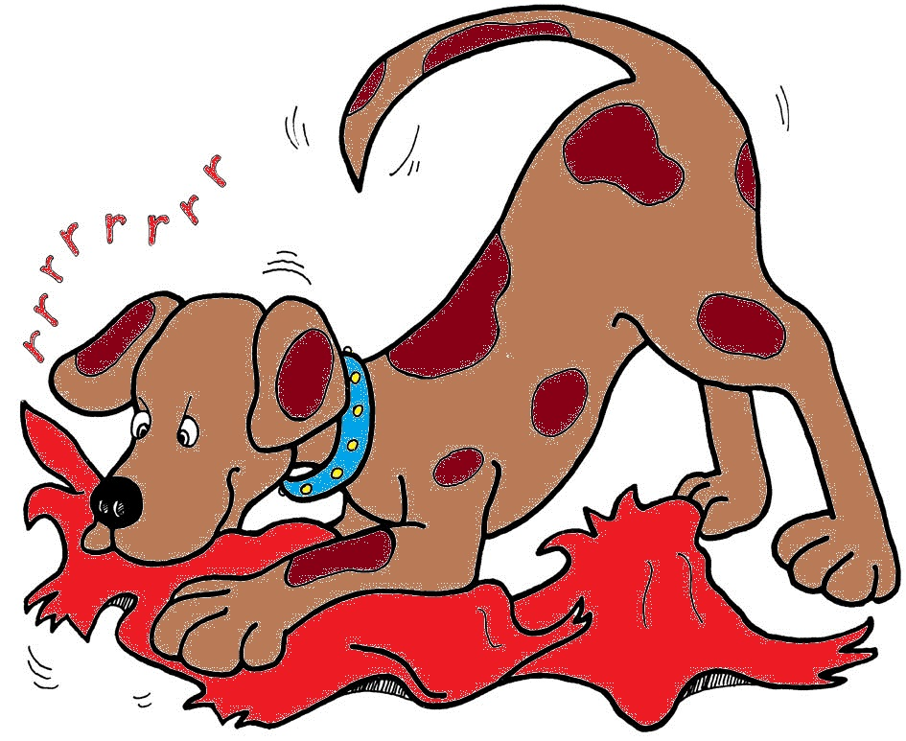 | Pretend to be a puppy, pulling a rag, and shake your head from side to side, saying rrrrrrrr.  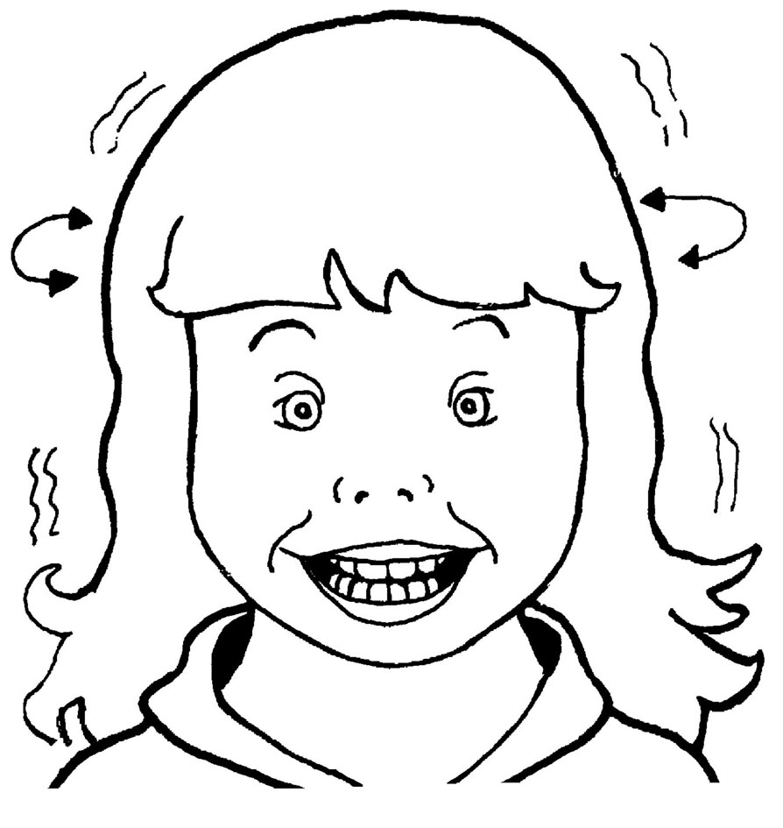 | (Tune: The Muffin Man)  See my puppy rip the rag.  /rrr/! /rrr/!  See my puppy rip the rag,  When he pulls so hard.

Letter Sound | Action | Song
g  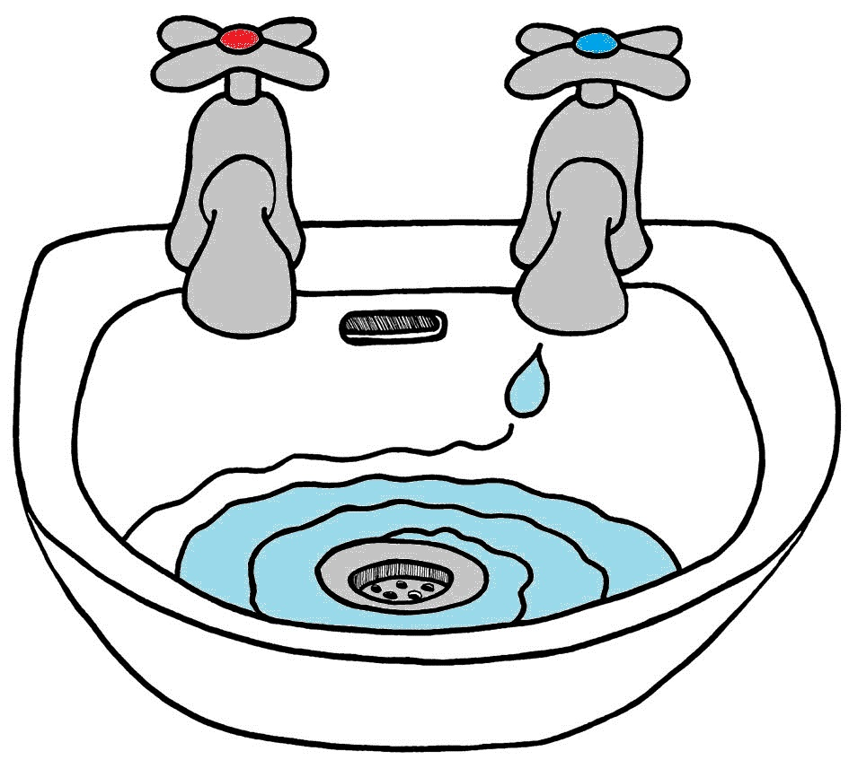 | Spiral your hand down, as if water is gurgling down a drain, and say g,g,g,g.  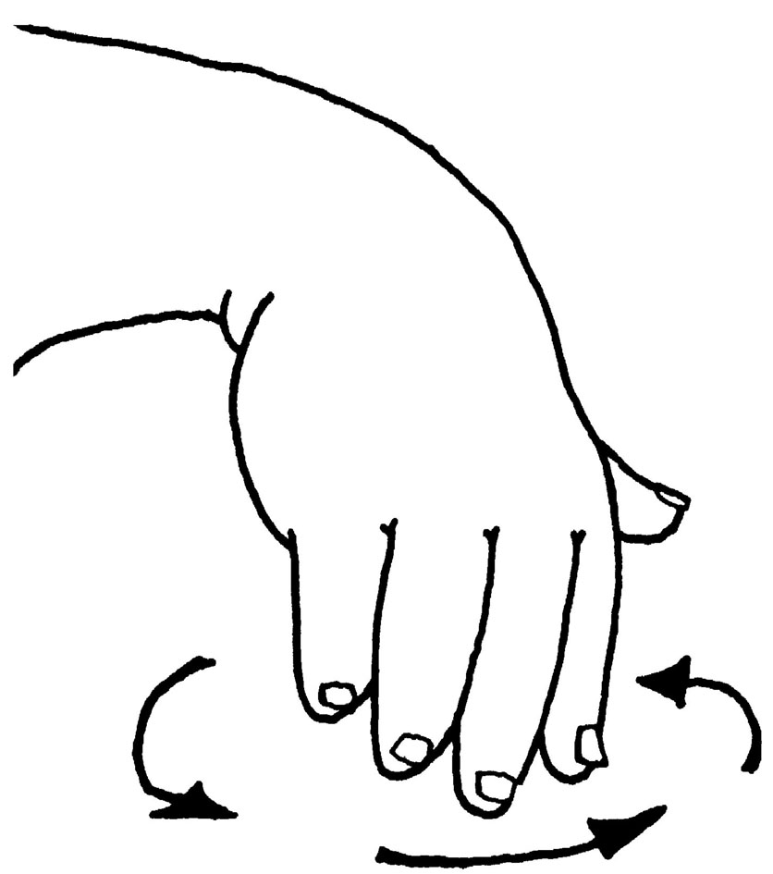 | (Tune: Jimmy Crack Corn)  The water gurgles down the drain.  The water gurgles down the drain.  The water gurgles down the drain,  with a /g/-/g/-/g/-/g/-/g/.

Letter Sound | Action | Song
o  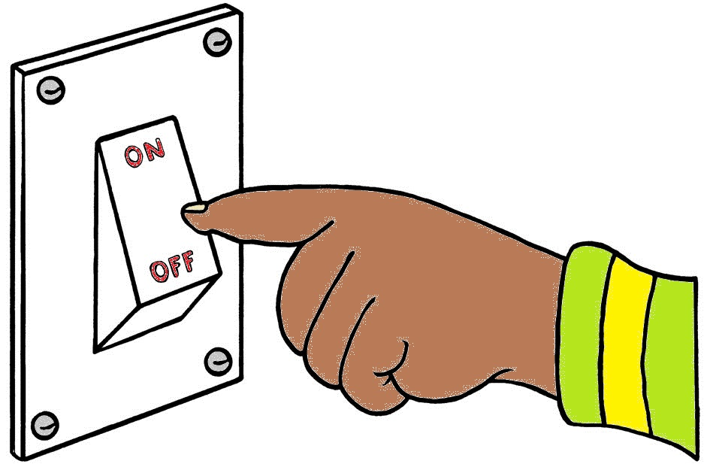 | Pretend to turn a light switch on and off, and say o,o,o,o.  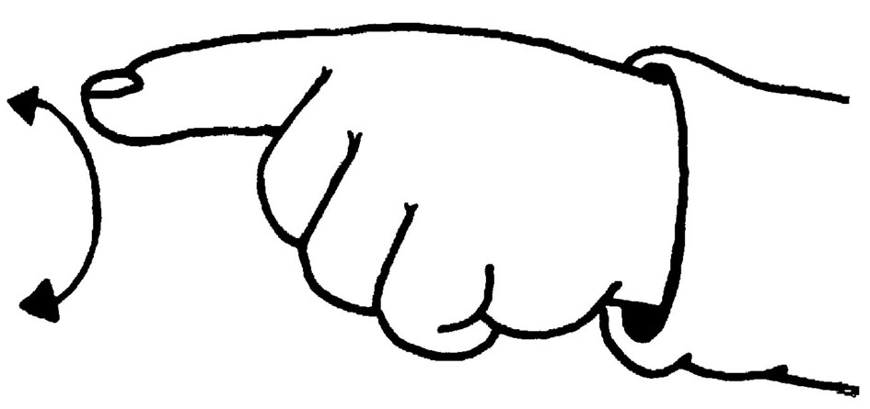 | (Tune: Old MacDonald)  Now it’s dark,  the lights go on.  /o/-/o/-/o/-/o/-/o/.  Time for bed,  the lights go off!  /o/-/o/-/o/-/o/-/o/.

